Task 3.1 - State-of-the-Art, Threat models/Attacks/Defences - Single model & Collaborative model paradigms

(Living document)
Single model paradigm 1
Data collection phase 2
Attacks 2
Data Bias 3
Fake Data 3
Data Breach 3
Sensor Spoofing Attack 3
Defences 3
Detection and Filtering 3
Data Provenance and Authentication 4
Standardized Management 4
Data pre-processing phase 4
Attacks 4
Data leakage 4
Scaling Attacks 5
ISA - Interpolation Algorithm 6
ISA - Poisoning attack 7
Defences 7
Data Leakage prevention 7
Image Reconstruction (ISA related) 8
Filtering and Detection (ISA related) 8
Training Phase 8
Overview 9
Poisoning Attacks and Defences 12
Attacks 12
Indiscriminate (Availability) Poisoning Attacks 12
Label-Flip Poisoning 13
Bilevel Poisoning 13
Bilevel Poisoning (Clean-Label) 14
Gradient-based Attacks 14
GAN-based Attacks 15
Targeted (Integrity) Poisoning Attacks 15
Bilevel Poisoning 16
Feature Collision (Clean-Label) 16
Bilevel Poisoning (Clean-Label) 16
Backdoor (Integrity) Poisoning Attacks 16
Trigger Poisoning 17
Bilevel Poisoning 18
Feature Collision (Clean-Label) 18
Model Manipulation Attacks 18
Defences 18
Training Data Sanitization 18
Robust Training 19
Model Inspection 19
Model Sanitization 20
Trigger Reconstruction 20
Test Data Sanitization 20
Inference Phase 20
Model Inversion Attacks 20
Model Inversion Attack Approaches 22
Optimization-Based Approach 22
Generative Adversarial Network (GAN)-Based Approach 22
Defences against Model Inversion Attacks 22
Training-time Defense Approaches 23
Differential privacy 23
Label Smoothing 23
Transfer learning-based defense 23
Inference-time Defense Approaches 24
Model output processing 24
Membership Inference Attacks 24
Membership Inference Attack Approaches 25
Binary Classifier-based Membership Inference Attacks 25
Metric-based Membership Inference Attacks 25
Defenses against Membership Inference Attacks 25
Confidence Score Masking 25
Regularization 26
Knowledge Distillation 26
Differential Privacy 26
Model Extraction Attacks 26
Model Extraction Attack Approaches 27
Model Attribute Extraction 27
Model Functionality Extraction 27
Defences against Model Extraction Attacks 27
Defenses using Perturbations 27
Input perturbation-base defenses 28
Output perturbation-base defenses 28
Defenses using Queries Observation and Detection 28
Adversarial Examples (a.k.a Evasion attacks) 28
White-Box Attacks 30
Optimization-Based Attacks 30
Gradient-Based Attacks 30
Basic Iterative Method 30
Saliency-Based Attacks 30
Advanced Optimization Attacks 30
Universal Perturbations 31
Adaptive Approaches 31
Black-Box Attacks 31
Adversarial Transformation Networks 31
Zero-Order Optimization 31
Hoodini 31
One Pixel 31
Adversarial Examples with Generative Models 31
Defences against Adversarial Examples 33
Adversarial Training 33
Defensive Distillation 33
Gradient Regularization 33
Feature Squeezing 33
Detectors 33
Data Randomization 34
Input Reconstruction Methods 34
PixelDefend 34
Defense-GAN 34
Integration Phase - System Integration Attacks 35
AI confidentiality 35
Code vulnerability protection 35
Model Tampering Attacks 36
Denial of Service Attacks 36
Table Summary 37
Collaborative model paradigm 37
Overview 38
Threat models of FL 40
Insider vs. Outsider 40
Client vs. Server 41
Attacker capabilities 41
Honest‑but‑curious vs. malicious 41
Collusion vs. No-collusion 42
Training phase vs. Inference phase (training-time vs. inference time) 42
Security Attacks 42
Untargeted/Non-directed Attacks 42
Byzantine Attacks 42
Targeted/Directed Attacks 43
Poisoning Attack 43
Data Poisoning 43
Label-flipping 43
Samples poisoning attack 43
Out-of-distribution attack 43
Model Poisoning 44
Random weight generation 44
Information leakage 44
Backdoor attacks 44
Summary 45
Privacy Attacks 45
Membership Inference Attacks 45
Gradient Ascent 46
Client Isolation 46
GAN-based attacks 46
Model Inversion Attacks 46
Deep leakage from gradient attacks 46
Gradient similarity attacks 46
Feature Inference Attacks (Reconstruction or Gradient Inversion Attacks) 47
Gradient-based Attacks 47
Parameter-based Attacks 47
Label-inference Attacks 47
Property Inference Attacks (Attribute Inference Attacks) 48
Population distribution 48
Individual distribution 48
Defences against Security and Privacy Attacks 48
Server Defences 48
Robust aggregation operators 48
Anomaly detection 49
Differential privacy 49
Less is more 50
Client Defences 50
Differential Privacy 50
Homomorphic encryption 50
Cluster-based methods 50
Adversarial training 51
Perturbation methods 51
Gradient compression 51
Random Sketching 51
Communication channel defences 51
Secure multi-party computation 51
Defence of anonymous channels 52
Blockchain based FL 52
Table Summary 52

Single model paradigm

The lifecycle of an AI system can be generally divided into five phases as illustrated in Figure 1: i) data collection, ii) data pre-processing, iii) model training, iv) model inference, and v) system integration, each of which is vulnerable to different sets of security threats.
Figure 1. The overall framework of attack and defense strategies for the AI systems.
The analysis describes extensively the five different security threat categories which correspond to the aforementioned phases of the lifecycle of an AI system: Data Collection Related Attacks, Scaling Attacks, Poisoning Attacks, Adversarial Example Attacks, System Integration Attacks.

Data collection phase
Data is the driving force behind the rapid development of AI. Data collection needs to meet the following security objectives: confidentiality, integrity, non-repudiation, authentication, privacy protection, and self-protection. Data Collection can be categorized into:
- Software-based data collection: relies on tools like crawlers and packet capture applications, where vulnerabilities in any component can compromise data quality.
- Hardware-based data collection: data collection devices include sensors, hardware probes, mobile terminals, data acquisition generation cards and so on. The potential threat of each type of data collection method varies according to the underlying design principle of the hardware. Sensors are the most widely used data collection tools, offering advantages such as efficiency and flexibility. However, sensor data collection is, for example, vulnerable to security threats such as sensor spoofing attacks. In such attacks, an attacker gains access to or tampers with the data provided by the sensors.

Attacks

Data Bias
AI is very sensitive to training data. Data source selection and data preparation may introduce bias. Data bias occurs when the collected data does not accurately represent the full diversity of the target population or scenario, often due to systemic flaws in the collection process. This can lead to skewed results, misinterpretations, and unfair outcomes in systems relying on the biased data for analysis or decision-making. Overall, AI biases undermine the integrity of the AI.

Fake Data
The issue of fake data—false or misleading information intentionally introduced into a system—is a challenge affecting the AI domain. Innovations in pooling functions and DNN structures enhance a model's ability to process and recognize subtle differences between real and fake data, making them essential for detecting and mitigating the impact of fake inputs.

Data Breach
A data breach—defined as the unauthorized access or acquisition of information by an external party, often resulting from a cyberattack or security lapse—can expose sensitive data, such as training data, compromising individuals' privacy and introducing risks like model inversion, where adversaries infer private data from the model. Additionally, leaked data can enable attackers to craft adversarial inputs or poison future training processes, thereby degrading the AI model’s performance and trustworthiness. It is worth noting that data breach is not only a problem specific to the data collection phase but can also occur during the training and inference phases of the model.

Sensor Spoofing Attack
Data generated from the physical world needs to be digitalized and collected using relevant sensor elements for subsequent model training and inference. Sensors are ubiquitously integrated into smart wearable devices, automated driving vehicles, and Light Detection and Ranging (LIDAR), which are the underlying core components responsible for data measurement and collection. Attackers can exploit the physical properties of sensors to construct malicious samples to spoof sensors to interfere with data collection. (e.g. a non-invasive spoofing attack through a regular channel. For instance, to mislead the sensor into producing a malicious speed, an attacker might block the magnetic field generated by the rotating gear on the left. The magnetic field generated by the malicious actuator that detects wrong speed is then transmitted to the Anti-lock Braking Sensor (ABS), which consequently leads to the sensor spoofing attack.).

Defences
Data collection can mitigate security threats by employing data security protection strategies in hardware security, software security, and cyber security. There is a wide variety of data collection protection strategies that can vary by scenario.

Detection and Filtering
Techniques such as rejecting object classification—a postprocessing method that provides favorable outcomes for unprivileged groups and unfavorable outcomes for privileged groups within a confidence band around the decision boundary with the highest uncertainty—or learning fair representation—instead of adjusting predictions afterward, it focuses on training the AI model to represent data in a way that is fair from the start—can help mitigate AI bias. Additionally, an example of mitigating the threat of a data breach is an unsupervised outlier detection technique, which identifies falsified data (identify data that looks suspicious or unusual without needing predefined labels, e.g., it can detect fake data that might have been added to compromise the system). In the domain of sensors, methods like sensor enhancement and baseband offset have been found to be effective in defending against sensor spoofing attacks.

Data Provenance and Authentication
Proper sensor trust mechanisms can be adapted to disable the data collected from untrusted devices or unauthorized devices. The trustiness of sensor nodes should be checked before aggregating data from them through trustworthiness evaluations. Another commonly used security mechanism is authentication.

Standardized Management
Human misuse can also affect the quality of collected data, which requires the management and training of relevant personnel. Therefore, we need to examine security requirements for data collection (confidentiality, integrity, identity verification, etc.) and develop corresponding management procedures to secure data collection.

Data pre-processing phase
The real-world data is generally incomplete, noisy and inconsistent. Data preprocessing involves cleaning and transforming raw data before training and testing machine learning (ML) models (scaling, normalization, and feature selection are commonly used preprocessing techniques).

Attacks

Data leakage
Data leakage occurs when information about the target variable (the dependent variable) is inadvertently or deliberately included in the features (independent variables) used to train the model. Any feature that directly or indirectly reveals the value the model aims to predict is considered a data leak, leading to misleadingly high performance and false results. If preprocessing techniques are applied to the entire dataset before splitting, the model will learn patterns from both the training and test sets, resulting in data leakage. Consequently, the model may perform exceptionally well on the test set but fail to generalize to unseen data.
A data leak can lead to the high-performance performance of ML models. However, these high-performance scores do not indicate the model’s ability to generalize to new, unseen data. The model may perform poorly in real-world scenarios, where the data is likely to differ from the test set, as it has been trained on an unrealistic data representation. Therefore, it is important to carefully handle data preprocessing and prevent data leakage to ensure that ML models are reliable and can generalize well to real-world situations.
Furthermore, data leakage can manifest in different ways, depending on the specific preprocessing techniques and the nature of the data. Some common ways data leakage can occur include:
Feature engineering leakage - occurs when new features are created using information from the entire dataset, including the test set. For example, creating interaction terms or aggregating features based on the whole dataset can lead to leakage, as the model will access information from the test set during training
Feature selection leakage - Leakage can also occur during feature selection if the criteria used to identify and eliminate irrelevant or redundant features are derived from the entire dataset, including the test set.
Target leakage - occurs when the target variable (the value the model aims to predict) is directly or indirectly present in the features used to train the model.
Data preprocessing leakage - Leakage can occur during data pre-processing steps, such as normalization and encoding, if these processes use information from the entire dataset, including the test set. For example, normalizing the data using the mean and standard deviation calculated from the entire dataset can introduce leakage.

Scaling Attacks
One representative attack is for the Image Scaling Attacks (ISAs), where an attacker tampers with the image and abuses the (visual) cognitive differences between humans and machines to achieve a spoofing and escape attack bypassing even careful manual inspection. (Even when a human manually inspects the image, they might not notice the tampering because the manipulation is designed to take effect only during machine processing, not in its original visual form.).

More specifically, the size of the image data used to train the models is usually fixed. For example, the image fed into the model is generally sized 224×224 or 32×32, which is smaller than the original—due to the image pre-processing step. In the data pre-processing phase, for example, the images need to be scaled to match the model input size. Image scaling generates a new image with lower/higher resolution in terms of pixels than the original while preserving the original visual features and scaling it proportionally. However, during the scaling process, attackers can misuse the scaling algorithm to adjust the pixel-level information to craft a camouflage image, resulting in a dramatic change in visual semantics before and after image scaling. Notably, the ISA is powerful enough to be agnostic to different models as long as they employ the same rescaling function to fit the same model input size. In the figure below, an attack image based on a sheep image was crafted that visually disguises the “wolf” as a “sheep”. Once the image is down-sampled or resized, the real “wolf” is revealed.

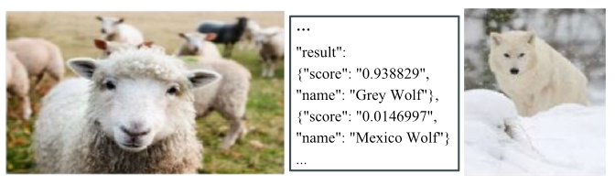
Figure 2. Example of a scaling attack. Source: Seeing is not believing: camouflage attacks on image scaling algorithms

ISA - Interpolation Algorithm
When images are resized (either enlarged or reduced), an interpolation algorithm is used to calculate the new pixel values. This process involves using the surrounding pixels' information to estimate how to adjust the image.

Image Scaling Attacks (ISA) take advantage of the process used by AI models to resize images, making them vulnerable to manipulation. Attackers can exploit the inverse of this interpolation algorithm to manipulate the image in such a way that, when resized, it tricks the model into misinterpreting the image. Essentially, the attacker alters the image before resizing it, embedding hidden patterns or features that only become visible after the image is scaled. This allows the attacker to insert misleading information without it being obvious to a human viewer, as the tampering only affects the machine's processing. Such an attack is still effective even when the deployed system is a black-box to the attacker, as it is relatively easy to infer required parameters such as the input image size or/and the underlying rescaling function used by that model through e.g., exhaustive trials. This is due to the fact that the commonly used type of input image sizes or/and rescaling functions are limited.
Figure 3 illustrates an example of how the attack works: i) a small change (called a perturbation matrix, ∆1) is first added to the original image “srcimg” (e.g., digit number 8) to create an altered image (the attack image, “attackimg”). This altered image hides the original image and includes the target image, like a 6 instead of 8. ii) then, another difference (∆2) is calculated between the target image “targetimg” (6) and the output image “outimg”. iii) Finally, the optimal attack image is generated based on the interpolation algorithm in the constraints of ∆1 and ∆2, that hides the target image and tricks the model into identifying it as the target (6). Once the image-scaling operation is routinely performed on the attack image, the model sees the targeted image e.g., digit number of 6, and thus identifies it as the attacker’s target of 6, which is a source-to-target attack.
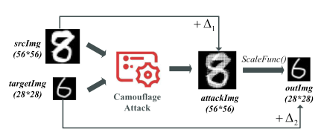
Figure 3. Automatic attack image crafting. Source: Seeing is not believing: camouflage attacks on image scaling algorithms

ISA - Poisoning attack
In this approach, attackers combine Image Scaling Attacks (ISA) with poisoning attacks to hide malicious elements, called "triggers" in images. The goal is to insert these poisoned images into the training data without being noticed, as illustrated in Figure 4. Normally, a poisoned image would have a trigger hidden within it, which, once detected by the AI model, would cause it to behave in a harmful way (called a backdoor attack). However, the ISA technique is used before the images are processed, manipulating them in such a way that the triggers are invisible to both the model and anyone inspecting the images manually. This is done by resizing the image in a specific way, so it looks normal and passes all checks. The trick is that the trigger is only revealed when the image is resized, and that's when the backdoor attack can be activated. So, by combining ISA with poisoning, the attacker ensures that the triggers remain hidden until the right moment, allowing the backdoor attack to take place without being detected earlier.

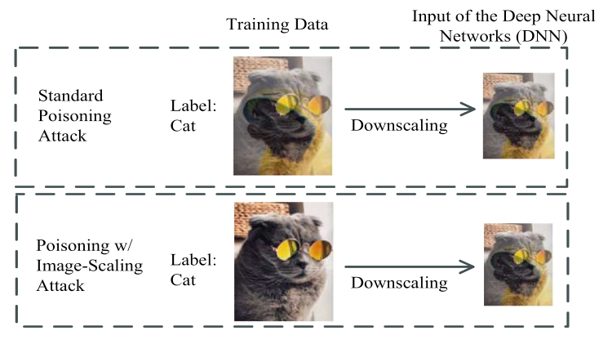
Figure 4. A clean-label poisoning attack. Source: Backdooring and poisoning neural networks with image-scaling attacks

Defences

Data Leakage prevention
To prevent data leakage in the preprocessing phase it is necessary to split the data early. By doing so, preprocessing steps (such as normalization or encoding) can be applied independently to the training set, and the same transformations can later be applied to the validation and test sets. This can be accomplished by utilizing a dedicated pipeline framework that processes the training and test data separately to avoid train-test contamination. The pipeline should include all necessary preprocessing steps, such as data cleaning, normalization, scaling, feature selection, and encoding, ensuring that the split data is handled independently at each stage.

Image Reconstruction (ISA related)
Selective median filters and random filters to identify pixel points that have been altered during scaling. After identifying the altered pixels, the method uses the median of surrounding pixels to reconstruct the original image, effectively replacing the tampered pixels with values that match the surrounding content.

Filtering and Detection (ISA related)
Image reconstruction prevents ISAs by the relationship between downsampling frequency and image scaling but degrades the quality of the input image. Therefore, as illustrated in Figure 5, the methods of rescaling, filtering and steganalysis are integrated into a scaling attack detection framework-decamouflage.

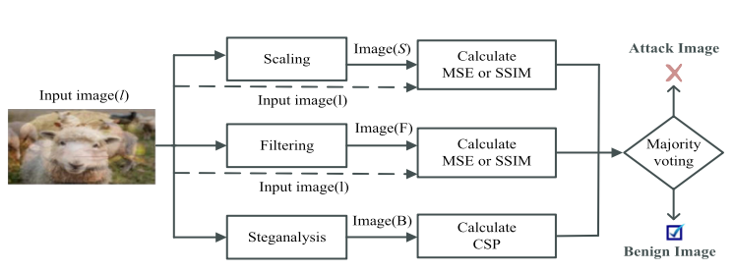
Figure 5. Overview of Decamouflage. Source: Decamouflage: A Framework to Detect Image-Scaling Attacks on Convolutional Neural Networks

Specifically, (i) Scaling detection method firstly performs downscaling and then upscaling operations on the input image to construct a “copy” image, then compares the similarity of the image on the color histogram before and after between the input image and its “copy”: The attacker injected pixels in the input image are expected to be removed fromthe “copy” attributing to the upscaling. (ii) Filtering detection filters the image using filters. (iii) The samples suspected to attack images are transformed into two-dimensional space by Discrete Fourier Transform (DFT) and perturbed pixels embedded by ISA are detected using steganalysis.
Subsequently, the Mean Squared Errors (MSE), Structural Similarity Index (SSIM), and Centered Spectrum Points (CSP) metrics are used to quantify the similarity before and after, and to derive detection boundaries for each detection method independently. Finally, an ensembled technique is performed to identify whether the incoming image is an attack image or not.

Training Phase

Overview
AI systems are trained based on large, curated data. However, the data quality directly affects the performance of the model trained. In this context, an attacker can poison the training set to manipulate the inference behavior of the model. From the perspective of the model and the attack target (i.e. what the attacker aims to disrupt or manipulate within the AI system when performing a poisoning attack), poisoning attacks can be divided into three categories:

- Untargeted/Indiscriminate (Availability) Poisoning Attacks
- Targeted (Integrity) Poisoning Attacks
- Backdoor (Integrity) Poisoning Attacks

In indiscriminate (availability) poisoning attacks (I), the attacker manipulates a fraction of the training data to maximize the classification error of the model on the (clean) test samples. The attacker’s goal is to cause misclassification on clean validation samples by injecting new malicious samples or perturbing existing ones in the training dataset. As a result, this attack aims to maximize the overall loss of the model and cause a degradation in model performance as well as misclassification.
Example: A spammer adds random noise or meaningless data to a dataset used to train an email spam filter. For instance, they label emails with gibberish content as both "spam" and "not spam." This confuses the model, causing it to fail in distinguishing spam from legitimate emails.

In targeted (integrity) poisoning attacks (II), the attacker manipulates again a subset of the training data, but this time to cause misclassification of a specific set of (clean) test samples. In contrast to indiscriminate poisoning, targeted poisoning attacks preserve the availability, functionality and behavior of the system for legitimate users, while causing misclassification of some specific target samples. Similarly to indiscriminate poisoning, targeted poisoning attacks manipulate the training data, but they do not require modifying the test data. In other words, the attacker accomplishes targeted damage by carefully designing poisoned data without affecting the model’s classification of clean samples.
Example: An attacker poisons a facial recognition model's training data by adding altered images of a specific person (e.g., wearing a particular hat) labeled as another person. The trained model then incorrectly identifies that person as someone else whenever they wear the same hat.
In backdoor poisoning attacks (III), the training data is manipulated by adding poisoning samples containing a specific pattern, referred to as the backdoor trigger, and labeled with an attacker-chosen class label. This typically induces the model to learn a strong correlation between the backdoor trigger and the attacker-chosen class label. Accordingly, at test time, the input samples that embed the trigger are misclassified as samples of the attacker-chosen class.
Example: An attacker inserts images of traffic signs with a small sticker or pattern into the training set and labels them incorrectly (e.g., a stop sign with a sticker labeled as a speed limit sign). The model learns to misclassify any stop sign with the same sticker as a speed limit sign, allowing the attacker to exploit this backdoor in specific scenarios.

The goal of a poisoning attack can be defined in terms of the intended security violation, and
the attack and error specificity:
Security Violation. It defines the security violation caused by the attack, which can be: (i) an integrity violation, if malicious activities evade detection without compromising normal system operation; (ii) an availability violation, if normal system functionality is compromised, causing a denial of service for legitimate users; or (iii) a privacy violation, if the attacker aims to obtain private information about the system itself, its users, or its data.
Attack Specificity. It determines which samples are subject to the attack. It can be: (i) sample-specific (targeted), if a specific set of sample(s) is targeted by the attack, or (ii) sample-generic (indiscriminate), if any sample can be affected.
Error Specificity. It determines how the attack influences the model’s predictions. It can be: (i) error-specific, if the attacker aims to have a sample misclassified as a specific class. The attacker manipulates the training data so that the model makes a very specific error. For example, if there is a clean input (C) with a correct label (y_{true}), the attacker tweaks the training data so that the model misclassifies C as a specific class chosen by the attacker (like targeting a clean picture of a cat and making the model always think it’s a dog).; or (ii) error-generic, if the attacker attempts to have a sample misclassified as any class different from the true class. For example, the model might classify the clean input (C) as something random, like a bird or a car, instead of its true label.

Learning Settings. There exist three main scenarios under which ML models can be trained, and which can pose serious concerns in relation to data poisoning attacks: (i) training-from-scratch, (ii) fine-tuning, and (iii) model-training.
- Training from Scratch (TS) and Fine Tuning (FT). In the training-from-scratch and fine-tuning scenarios, the user controls the training process, but collects the training data from external repositories, potentially compromised by attackers. In practice, these are the cases where data gathering and labeling represent time-consuming and expensive tasks that not all organizations and individuals can afford, forcing them to collect data from untrusted external sources. The distinction between the two scenarios hinges on how the collected data is employed during training. In the training-from-scratch scenario, the collected data is used to train the model from a random initialization of its weights. In the fine-tuning setting, instead, a pretrained model is typically downloaded from an untrusted source and used to map the input samples on a given representation space induced by a feature mapping function 𝜙. Then, a classification function 𝑓 is fine-tuned on top of the given representation 𝜙.
- Model Training (MT). In the model-training (outsourcing) scenario, the user is supposed to have limited computational capacities and outsources the whole training procedure to an untrusted third party, while providing the training dataset. The resulting model can then be provided either as an online service which the user can access via queries or given directly to the user. In this case, both the feature mapping 𝜙 and the classification function 𝑓 are trained by the attacker (i.e., the untrusted party). The user, however, can validate the model’s accuracy on a separate validation dataset to ensure that the model meets the desired performance requirements.

Attacker’s Knowledge. The attacker may get to know some details about the target system, including information about: (i) the (clean) training data D, (ii) the ML model M being used, and (iii) the test data T. The first component considers how much knowledge the attacker has on the training data. The second component refers to the ability of the attacker to access the target model, including its internal (trained) parameters 𝜽, but also additional information like hyperparameters, initialization, and the training algorithm. The third component specifies if the attacker knows in advance (or has access to) the samples that should be misclassified at test time.

Attack Strategy. The attack strategy defines how the attacker manipulates data to stage the desired poisoning attack. Both indiscriminate and targeted poisoning attacks only alter the training data, while backdoor attacks also require embedding the trigger within the test samples to be misclassified.

Defender’s Goal. The defender’s goal is to preserve the integrity, availability, and privacy of their ML model, i.e., to mitigate any kind of security violation that might be caused by an attack. The defender thus adopts appropriate countermeasures to alleviate the effect of possible attacks, without significantly affecting the behavior of the model for legitimate users.

Defense Strategy. The defense strategy defines how the defender operates to protect the system from malicious attacks before deployment (i.e., at training time), and after the model’s deployment (i.e., at test time). There exist six distinct categories of defenses:
- training data sanitization, which aims to remove potentially harmful training points before training the model;
- robust training, which alters the training procedure to limit the influence of malicious points;
- model inspection, which returns for a given model whether it has been compromised (e.g., by a backdoor attack);
- model sanitization, which cleans the model to remove potential backdoors or targeted poisoning attempts;
- trigger reconstruction, which recovers the trigger embedded in a backdoored network;
- test data sanitization, which filters potentially triggered samples presented at test time.

These defenses essentially work by either (i) cleaning the data or (ii) modifying the model. In the former case, the defender aims to sanitize training or test data. Training data sanitization and test data sanitization are the two strategies adopted respectively at training and at test time to mitigate the influence of data poisoning attacks. Alternatively, the defender can act directly on the model, by (i) identifying possible internal vulnerabilities and removing/fixing components that lead to anomalous behavior/classifications, or by (ii) changing the training procedure to make the model less susceptible to training data manipulations. The first approach is employed in model inspection, trigger reconstruction and model sanitization defensive mechanisms. The second approach, instead, includes algorithms that operate at the training level to implement robust training mechanisms.

Poisoning Attacks and Defences
Figure 6 presents preliminary, high-level categorization of attacks and defenses. This taxonomy categorizes attacks and defenses based on whether they are applied at training time (and in which learning setting) or at test time; whether the attack aims to violate integrity or availability; and whether the defense aims to sanitize data or modify the learning algorithm/model. As one may note, indiscriminate and targeted poisoning only manipulate data at training time to violate availability and integrity, respectively, and they are typically staged in the training-from-scratch (TS) or fine-tuning (FT) learning settings. Backdoor attacks, in addition, require manipulating the test data to embed the trigger and cause the desired misclassifications, with the goal of violating integrity. Such attacks can be ideally staged in any of the learning settings considered. For defenses, data sanitization strategies can be applied either at training time or at test time, while defenses that modify the learning algorithm or aim to sanitize the model can be applied clearly only at training time (i.e., before model deployment).

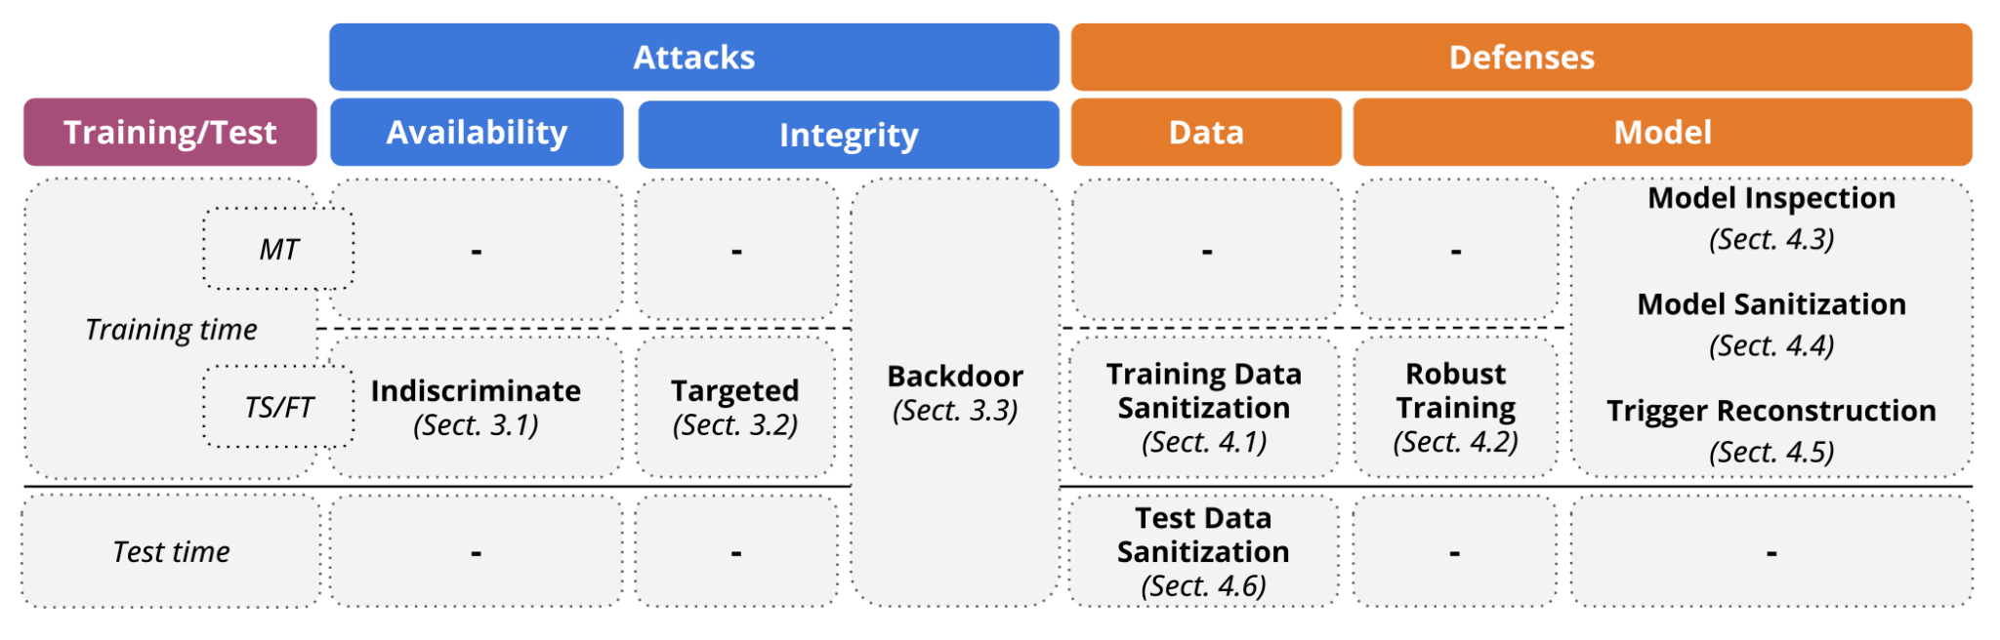
Figure 6. Conceptual overview of poisoning attacks and defenses. Attacks are categorized based on whether they compromise system integrity or availability. Defenses are categorized based on whether they sanitize data or modify the learning algorithm/model. Training-time (test-time) defenses are applied before (after) model deployment. Training-time interventions are also divided according to whether model-training (MT) is outsourced, or training-from-scratch (TS) / fine-tuning (FT) is performed. Source: Wild Patterns Reloaded: A Survey of Machine Learning Security against Training Data Poisoning

Attacks

Indiscriminate (Availability) Poisoning Attacks
The attacker aims to subvert the system functionalities, compromising its availability for legitimate users by poisoning the training data. More concretely, the attacker’s goal is to cause misclassification on clean validation samples by injecting new malicious samples or perturbing existing ones in the training dataset.

Availability attacks with poisoning can be formally represented as a bi-level optimization problem.
- Inner Optimization: This step trains the model on the poisoned data (adding the attacker’s malicious samples to the training set).
- Outer Optimization: The attacker tries to maximize the "damage" caused by the poisoned training, focusing on increasing the classification error on clean data.
Objective (goal) of the attacker:
- The attacker’s goal is to make the model perform poorly on clean data. Specifically, this is done by maximizing a loss function, which measures how bad the model’s predictions are on clean data after being trained on poisoned data.
An attacker poisons a linear street-sign classifier to have stop signs misclassified as speed limits. The adversary injects poisoning samples to rotate the classifier’s decision boundary, thus compromising the victim’s model performance. | 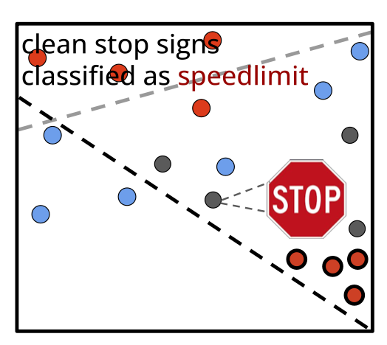

Label-Flip Poisoning
The most straightforward strategy to stage poisoning attacks against ML is label-flip. The adversary does not perturb the feature values, but they mislabel a subset of samples in the training dataset, compromising the performance accuracy of ML models.
More specifically, the attacker intentionally assigns incorrect labels to a subset of samples in the training data. The attacker does not alter the actual data points (features) themselves. For example, the image of a cat remains a cat, and the image of a dog remains a dog. The attacker changes the labels of some data points to incorrect ones. For instance: A cat image is labeled as "dog." or a stop sign is labeled as a "yield sign". The poisoned training data causes the model to learn incorrect mappings between features and labels. This leads to reduced performance and accuracy, as the model becomes confused about what features correspond to which labels. Label-flipping is easy to execute because the attacker doesn't need to modify the data itself, only the labels. The attack is particularly effective in scenarios where the dataset has little or no validation, and mislabeled data can go unnoticed.
Example: Imagine training a model to classify emails as "spam" or "not spam." An attacker flips the labels of some "not spam" emails to "spam" and vice versa. The model learns from this poisoned data, leading to incorrect classifications, such as legitimate emails being flagged as spam.

Bilevel Poisoning
In this case, the attacker manipulates both the training samples and their labels. More specifically, the attacker alters the actual data points (features) in addition to changing their labels. For example, the image of a cat might be modified to look like a dog (i.e., changing the features of the sample). A stop sign image might be slightly altered so it’s harder for the model to recognize it correctly. As in label-flip poisoning, the attacker also changes the labels of these samples. In this case, the altered data (e.g., the modified cat image) might be incorrectly labeled as a "dog." By modifying both the features and labels, the attacker introduces double confusion. The model is misled both by incorrect representations of the data and by incorrect associations between features and labels. This makes bilevel poisoning more effective than simpler attacks (like label-flip), because the model is being misled on two fronts. The model might learn to misclassify certain patterns or features entirely, leading to a significant degradation in accuracy.
Example: Imagine an attacker trying to sabotage a self-driving car's object detection system. The attacker could modify images of stop signs, perhaps changing their shape slightly (e.g., skewing or blurring them) and simultaneously label these modified stop signs as "yield signs". The model will then learn to misclassify stop signs as yield signs, causing a dangerous error in the real world.

Bilevel Poisoning (Clean-Label)
Bilevel Poisoning assumes that the attacker has access to a small percentage of the training data and can alter both features and labels. Similar attacks have been staged by assuming that the attacker can control a much larger fraction of the training set, while only slightly manipulating each poisoning sample to preserve its class label, i.e., performing a clean-label attack. More specifically, in a clean-label attack, the attacker doesn't change the class label of the samples directly but only makes slight manipulations to the features.The attacker has access to only a small percentage of the training data, rather than the entire dataset. The attacker can modify the features (i.e., the actual data points) of these selected samples, but does not change their class labels. For example, the attacker might slightly alter the pixels in an image or adjust the numerical values in a dataset. In a self-driving car’s object detection system, the attacker could slightly distort the features of a stop sign image (e.g., by changing its color or shape subtly), but the label ("stop sign") remains the same. The feature manipulation is designed to confuse the model during training. The idea is to subtly shift the model’s decision boundary without directly changing the labels. Since the class labels are not altered, the model may not immediately detect the manipulation. However, the subtle feature modifications will cause the model to make incorrect predictions or misclassifications on new, similar data in the future.
Example: The attacker has a few images of cats and dogs in the training data. They slightly alter the images of cats by adding noise or changing some pixels, while keeping the "cat" label intact. The model will now learn to incorrectly classify certain types of cats as dogs, even though the label for the sample is still correct.

Gradient-based Attacks
These attacks exploit the gradients of the loss function to manipulate the training data in a way that degrades the model's performance. Specifically, adversaries can introduce malicious samples into the training dataset, which are crafted to maximize the model's error during the training phase. This manipulation can lead to a model that is less reliable or completely fails to function as intended when deployed in real-world scenarios. Research indicates that even a small fraction of poisoned data can severely compromise the model's accuracy and overall effectiveness, highlighting the vulnerability of machine learning systems to such attacks.

More specifically, gradients are “mathematical tools” used in machine learning during the training process to adjust the model's parameters.
- gradient is a guide or direction that tells the model how to adjust itself to improve its predictions
- gradients are derived from a mathematical function called the loss function, which measures how far off the model's predictions are from the correct answers.
- gradient tells the model how much and in what direction (increase or decrease) it should adjust its internal parameters (weights and biases) to make better predictions.
- gradients help the model learn by showing how to tweak its parameters, so the loss (error) becomes smaller.
  - This process is done iteratively during training using an algorithm like gradient descent.
- How an attacker exploits this:
  - In a gradient-based attack, the attacker reverses this process. Instead of using gradients to improve the model, they use them to figure out how to craft malicious samples that maximize the model's loss.
    - These malicious samples are carefully designed to "fool" the model into learning incorrect patterns or behaving unpredictably.

Example: The model is trying to classify images of cats and dogs. Normally, gradients help the model improve by learning features like fur patterns, ears, or shapes. Without an attack: Gradients adjust the model to better recognize cats and dogs. With a gradient-based attack: The attacker uses gradients to figure out how to introduce poisoned images (e.g., slightly altered images of dogs) that teach the model to incorrectly classify dogs as cats.

GAN-based Attacks
Generative Adversarial Networks (GANs) have emerged as a sophisticated tool for executing poisoning attacks, particularly in the context of availability. In this approach, adversaries utilize GANs to generate high-quality synthetic data that can be injected into the training dataset. This synthetic data is designed to mislead the learning process, causing the model to learn incorrect patterns or associations that ultimately degrade its performance. The effectiveness of GAN-based attacks lies in their ability to produce data that closely resembles legitimate samples, making it challenging for existing detection mechanisms to identify the malicious intent behind the injected data. Studies have shown that these attacks can significantly disrupt the training process, leading to models that are not only inaccurate but also potentially harmful when deployed in critical applications, such as healthcare or autonomous systems.

Targeted (Integrity) Poisoning Attacks
In contrast to indiscriminate (availability) poisoning, targeted poisoning attacks preserve the availability, functionality and behavior of the system for legitimate users, while causing misclassification of some specific target samples. Similarly to indiscriminate poisoning, targeted poisoning attacks manipulate the training data, but they do not require modifying the test data.
The classifier’s decision function for clean samples is not significantly changed after poisoning, preserving the model’s accuracy. However, the model isolated the target stop sign (grey) to be misclassified as a speed-limit sign. The system can still correctly classify the majority of clean samples, but outputs wrong predictions for the target stop sign. | 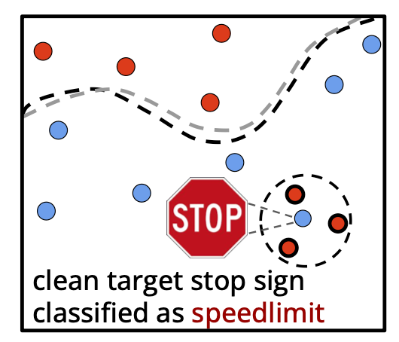

Bilevel Poisoning
Within this formulation, the attacker optimizes the perturbation 𝜹 on the poisoning samples in training set D𝑝 to have a set of target (validation) samples V𝑡 (Attacker target samples in validation dataset) misclassified, while preserving the accuracy on the clean (validation) samples in V. It is worth remarking here that the attack is optimized on a set of validation samples and then evaluated on a separate set of test samples. The underlying rationale is that the attacker cannot typically control the specific realization of the target instances at test time (e.g., if images are acquired from a camera sensor, the environmental and acquisition conditions cannot be controlled), and the attack is thus expected to generalize correctly to that case.

Feature Collision (Clean-Label)
This category of attacks is based on a heuristic strategy named feature collision, suited to the so-called fine-tuning (FT) scenario, which avoids the need of solving a complex bilevel problem to optimize poisoning attacks. This attack amounts to creating a poisoning sample 𝒙 + 𝜹 (𝜹 is training data perturbation) that collides with the target test sample 𝒛 ∈T (Test samples) in the feature space, so that the fine-tuned model predicts 𝒛 according to the poisoning label associated with 𝒙. To this end, the adversary leverages the model’s feature extractor 𝜙 to minimize the distance of the poisoning sample with the target in the feature space.

Bilevel Poisoning (Clean-Label)
Although feature collision attacks are effective, they may not result in optimal accuracy, and they do not minimize the number of poisoned points to change the model’s prediction on a single test point.
While feature collision methods relied on minimizing the feature space distance between the poisoned sample and the target, this kind of attack goes beyond this by directly optimizing the attack to mislead the final model prediction through bilevel optimization.

Backdoor (Integrity) Poisoning Attacks
Backdoor poisoning attacks aim to cause an integrity violation. In particular, for any test sample containing a specific pattern, i.e., the so-called backdoor trigger, they aim to induce a misclassification, without affecting the classification of clean test samples. The backdoor trigger is clearly known only to the attacker, making it challenging for the defender to evaluate whether a given model provided to them has been backdoored during training or not.

More specifically, these attacks involve an adversary manipulating the training process to implant a hidden behavior within the model, which is triggered by specific input patterns known as "triggers" or "backdoor keys". The fundamental mechanism of backdoor attacks is the poisoning of the training dataset, where the attacker injects malicious samples that are associated with a specific trigger and a target label. During inference, when the model encounters an input containing the trigger, it misclassifies the input according to the attacker's predetermined target label, while still performing correctly on untainted inputs.

Recent studies have highlighted the versatility of backdoor attacks across various domains, including image classification, natural language processing, and even reinforcement learning. For instance, in image classification tasks, backdoor triggers can be as simple as a specific pattern or noise added to an image, which the model learns to associate with a particular class. In natural language processing, triggers can be syntactic patterns embedded within text, allowing the adversary to manipulate the model's outputs without altering its performance on standard inputs. Furthermore, the emergence of federated learning has introduced new challenges, as the decentralized nature of this approach can make it difficult to detect and mitigate backdoor attacks, allowing malicious clients to introduce poisoned updates to the global model.
The attacker provides a backdoored street-sign detector that has good accuracy for classifying street signs in most circumstances. However, the classifier has successfully learned the backdoor data distribution and will output speed-limit predictions for any stop-sign containing the backdoor trigger. | 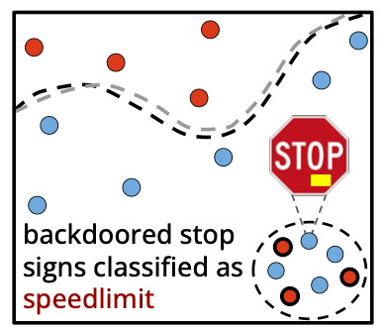

Trigger Poisoning
There exist three main families of backdoor triggers, i.e., patch, functional, and semantical triggers.
Patch. The first threat vector of attack for backdoor poisoning. In this case the user outsources the training process of a DNN to a third-party service, which maliciously alters the training dataset to implant a backdoor in the model. To this end, the attacker picks a random subset of the training data, blends the backdoor trigger into them, and changes their corresponding labels according to an attacker-chosen class.

Functional. The patch strategy is based on the idea that poisoning samples repeatedly present a fixed pattern as a trigger, which may however be detected upon human validation of training samples. In contrast, a functional trigger represents a stealthier strategy as the corresponding trigger perturbation is slightly spaced throughout the image or changes according to the input. Some works assume to slightly perturb the entire image so that those small variations are not detectable by humans, but evident enough to mislead the model.

Semantical. The semantical strategy incorporates the idea that backdoor triggers should be feasible and stealthy. For example, at training time, the backdoor trigger is injected into the training data to cause the model to associate a smile filter with the authorization of a user. At test time, the attacker can use the same filter to mislead classification.

Bilevel Poisoning
Trigger-based strategies assume that the attacker uses a predefined perturbation to mount
the attack. However, an alternative strategy for the attacker is to learn the trigger/perturbation itself to enhance the backdoor effectiveness.

Feature Collision (Clean-Label)
The backdoor trigger visibility influences the stealthiness of the attack. A backdoor trigger that is too obvious can be easily spotted when the dataset is inspected. However, several research suggests hiding the trigger into natural target samples. Specifically, the attacker first injects a random patch trigger into the training set, and then each poisoning sample is masked via feature collision. The resulting poisoning images are visually indistinguishable from the target, and have a consistent label (i.e., they are clean-label), while the test samples with the patch trigger will collide with the poisoning samples in feature space, ensuring that the attack works as expected.

Model Manipulation Attacks
Model manipulation attacks involve deliberate modifications to a model’s latent activations or weights to activate hidden or harmful capabilities. Unlike input-space attacks, which rely on crafted inputs to provoke malicious behavior, adversarial model manipulation directly exploits the internal mechanics of a model to embed dangerous behaviors. Attackers can deploy latent-space attacks, subtly modifying hidden activations to steer the model’s internal decision-making processes, or leverage weight-space attacks, to fine-tune the model with an adversarial objective.

Defences

Training Data Sanitization
These defenses aim to identify and remove poisoning samples before training, to alleviate the effect of the attack. The underlying rationale is that, to be effective, poisoning samples have to be different from the rest of the training points. Otherwise, they would have no impact at all on the training process. Accordingly, poisoning samples typically exhibit an outlying behavior with respect to the training data distribution, which enables their detection. The defenses that fall into this category require access to the training data D′ (Poisoned training set), and in a few cases also access to clean validation data V, i.e., to an untainted dataset that can be used to facilitate detection of outlying poisoning samples in the training set. Theoretically, these defenses can be applied in all learning settings.
Defences against availability (untargeted) attacks include label propagation and outlier detection. Detection can also be eased by taking into account both features and labels, using clustering techniques for availability and backdoor/targeted attacks. Backdoor and targeted poisoning attacks can also be detected using outlier detection, where the outlier is determined in the networks’ latent features on the potentially tampered data.

Robust Training
Another possibility to mitigate poisoning attacks is during training. The underlying idea is to design a training algorithm that limits the influence of malicious samples and thereby alleviates the influence of the poisoning attack. Intuitively, all of these defenses require access to the training data D′ (Poisoned training set) and none to clean validation data V. Nonetheless, they require altering the learning algorithm W and access to the model’s parameters 𝜽. Hence, robust training can only be implemented when the defender trains the model, e.g., in the training-from-scratch or fine-tuning setting.
To alleviate the effect of indiscriminate poisoning attacks, the training data can be split into small subsets. The high-level idea is that a larger number of poisoning samples is needed to alter all small classifiers. The defender can build such ensembles using bagging or voting mechanisms or a combination thereof. Other techniques exclude a sample from training if it leads to a significant decrease in accuracy when used in training. In addition, techniques can be applied from robust optimization and robust statistics, thereby limiting the impact of individual, poisonous points. Alternatively, the influence of poisons can be limited by increasing the level of regularization. Backdoor and targeted poisoning attacks can also be mitigated using data augmentations like mix-up or based on the model’s gradients wrt the input. Analogously, the data can be augmented using noise to mitigate indiscriminate and backdoor attacks. Furthermore, differences in the loss between backdoored/targeted and clean data allows to unlearn or identify poisons later in training. Alternatively, a trained preprocessor can alleviate the threat of backdoors. Finally, in both indiscriminate and backdoor/targeted attacks, the framework of differential privacy can be used to alleviate the effect of poisoning. The intuition behind this approach is that differential privacy limits the impact individual data points have, thereby limiting the overall impact of outlying poisoning samples too.

Model Inspection
Starting with model inspection, we discuss groups of defenses operating before the model is deployed. The approaches in these groups mitigate only backdoor and targeted attacks. In model inspection, we determine for a given model whether a backdoor is implanted or not.
In principle, model inspection can be used in all learning settings, where exceptions for specific defenses might apply. To inspect a model can be formulated as classifications tasks. For example, researches have shown that crafting specific input patterns and training a meta-classifier on the outputs of a given model computed on such inputs can reveal whether the model is backdoored. A different observation is that when relying on the backdoor trigger to output a class, the network behaves somehow unusual: it will rely on normally irrelevant features. Thus, outlier detection can be used. To detect backdoors and backdoored models, outlier detection can be used on top of interpretability techniques, or latent representations. Alternatively, finding a trigger that is reliably misclassified indicates the model is backdoored.

Model Sanitization
Once a backdoored model is detected, the question becomes how to sanitize it. To sanitize a model, pruning, retraining, or fine-tuning can be used. Given knowledge of the trigger, another research proposes to relabel the identified poisoned samples after the trigger is removed. Alternatively, approaches such as data augmentation or distillation can augment small, clean datasets.

Trigger Reconstruction
As an alternative to model sanitization, this category of defenses aims to reconstruct the implanted trigger. As for model inspection, trigger reconstruction can in theory be used in all learning settings. While a trigger can be randomly generated, the question remains on how to verify that the reconstructed pattern is a trigger. Many techniques leverage the fact that a trigger changes the classifier’s output reliably-backdoor patterns lead to a very stable or smooth output of the target class. In other words, the classifier ignores other features and only relies on the backdoor trigger. Such a stable output also enables to reformulate trigger reconstruction as an optimization problem. This kind of approach optimizes a pattern that leads to reliable misclassification of a batch of input points. The idea is that if there is such a pattern, and it is small, it must be similar to the backdoor trigger. Another research establishes that not an optimization, but also a GAN can be used to generate triggers. In general, a reconstruction can be based on the intuition that triggers themselves form distributions that can be learned.

Test Data Sanitization
As the name suggests, this is the only group of defenses operating during test time, where the defender attempts to sanitize malicious test inputs. This group can, in principle, be applied in all learning scenarios, but is the only sanitization applicable if the model is only available as an online service, and accessible via queries. There are three strategies overall when sanitizing test data. The first one boils down to removing the trigger. For example, there exist interpretability techniques that identify crucial parts of the input and then mask these to identify whether they are adversarial or not. A second group is built on the agreement of ensembles on input. Finally, and as used for trigger generation, the consistency of a classifier’s output can also help to detect an attack. While some research superimposes images to check consistency, others propose considering the consistency of noised images within the inner layers instead.

Inference Phase

Model Inversion Attacks
A Model Inversion Αttack refers to a type of adversarial attack in machine learning where the goal is to infer or reconstruct the original training data used to train a model. Given a trained model f_{θ​} and some prior knowledge K, the attacker seeks to derive a reverse hypothesis f_{ϕ}⁻¹ that, when applied to the model and the available information, produces an estimated set of training data X^_{train} . Formally, this can be expressed as f_{ϕ}⁻¹ (f_{θ},K) = X^_{train} where the resulting X^_{train} ​ is a set of data samples that approximates the original training samples X_{train}. By exploiting the model and any available prior information, the attacker aims to generate data that closely resembles the actual samples used during training. This raises privacy concerns, as it can potentially expose sensitive information about individuals or entities in the training dataset.
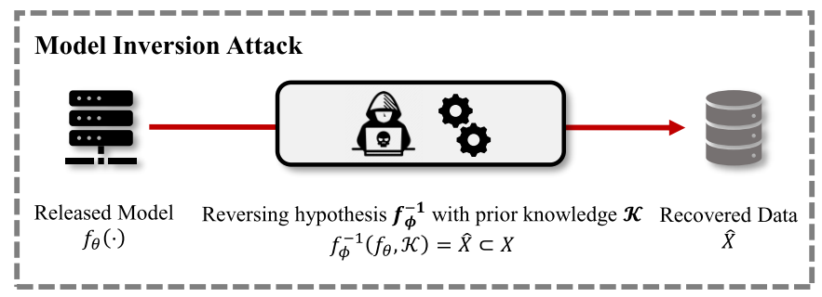
Figure 7. Given a released model trained on private data, Model Inversion Αttack is to find a reverse hypothesis to recover its training data. Source: Model Inversion Attacks: A Survey of Approaches and Countermeasures

Example of Model Inversion Αttacks on standard classification: In a specific type of model inversion attack, an adversary attempts to reconstruct sensitive training images by exploiting access to a well-trained target model. The attacker uses optimization-based techniques, particularly gradient-based optimization, to transform random noise into an image that the model classifies with high confidence as belonging to a specific class. This approach is common in a white-box setting, where the attacker knows the model’s internal details, such as its parameters and gradients. By iteratively refining the noise, the attacker generates an image that closely resembles the original training data for the target class, highlighting the potential privacy risks of such attacks.
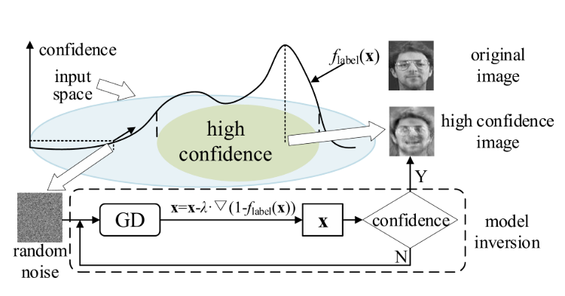
Figure 8. Model Inversion Αttacks on standard classification. Source: Model Inversion Attacks: A Survey of Approaches and Countermeasure


Figure 9. An image recovered using a new model inversion attack (left) and a training set image of the victim (right). The attacker is given only the person’s name and access to a facial recognition system that returns a class confidence score. Source: Model Inversion Attacks that Exploit Confidence Information and Basic Countermeasures

Model Inversion Attack Approaches

Optimization-Based Approach
Optimization-based Model Inversion Attacks, targeting models trained on sensitive data like facial images. This approach involved performing inversion optimization in the input space by gradually modifying an initial input to maximize the model’s confidence for a target label.

Generative Adversarial Network (GAN)-Based Approach
A model Inversion Attack using GANs leverages the powerful generative capabilities of Generative Adversarial Networks (GANs) to reconstruct private data more effectively. Rather than reconstructing private data from scratch, this method uses public information, which can be very generic, to learn a distribution prior via generative adversarial networks and use it to guide the inversion process.

Defences against Model Inversion Attacks
Model Inversion Αttacks pose a significant risk of privacy leakage in training data, making the development of privacy-preserving techniques an urgent need. Various approaches have been proposed to defend against Model Inversion Αttacks. These approaches can generally be categorized as training-time defense approaches and inference-time defense approaches.

Training-time defense approaches typically consider white-box defense scenarios, aiming to reduce the correlation between inputs and outputs by either limiting the amount of information flowing into the deep neural network from the input data or adding noise to the training-time information flow.
Inference-time defense approaches primarily address black-box defense scenarios, aiming to reduce the correlation between inputs and outputs by perturbing the model’s outputs.

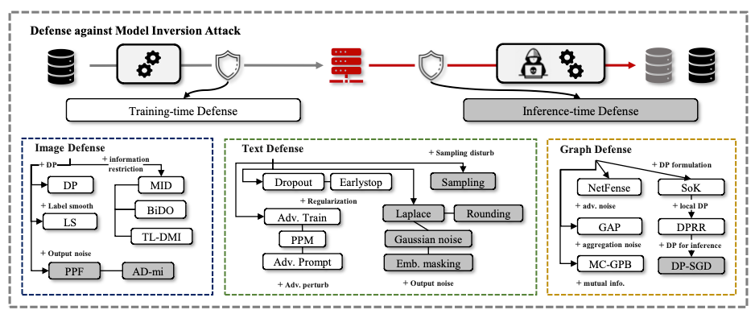
Figure 10. An illustration of defense against model inversion attacks and brief taxonomy regarding the methods across different domains. Source: Model Inversion Attacks: A Survey of Approaches and Countermeasure

Training-time Defense Approaches

Differential privacy
(DP) is a privacy-preserving technique with theoretical guarantees designed to protect against attempts to infer whether a data record is included in the training set from the trained model. This is done by adding noise to various values or parameters. This addition of noise masks the information and provides theoretical guarantees for the privacy of the training data. However, DP does not aim to protect the entire data distribution. Empirical investigations have demonstrated that DP fails to sufficiently protect against Model Inversion Αttacks while preserving desirable model utility.

Label Smoothing
Another privacy preservation defense method that can be used at training time is label smoothing. Label smoothing involves slightly modifying the target labels during training to prevent the model from becoming overly confident in its predictions. They found that using a positive smoothing factor can actually increase the risk of privacy leakage, particularly when the training dataset is small. On the other hand, applying a negative smoothing factor helps improve the model's robustness. This method ensures the model maintains high confidence across most regions, except near decision boundaries, which causes inversion attacks to produce results that deviate significantly from the original training data, reducing the attack’s effectiveness.

Transfer learning-based defense
A defense against model inversion attacks involves using transfer learning to enhance robustness. It was observed that the early layers of a model capture general features and can leak private information, while the later layers handle specific classification tasks. The proposed approach involves pre-training a model on a public dataset and then fine-tuning only the final layers using the private dataset, keeping the early layers fixed. This method reduces the risk of encoding sensitive information from private data and provides a better balance between model performance and privacy protection.

Inference-time Defense Approaches

Model output processing
Model output processing can reduce the private information carried in the victim model’s output vector in order to promote privacy. The output of the model can be processed either by adding adversarial noise or by removing it. Indeed, a proposed defense strategy involves training an autoencoder to purify the output vectors by minimizing their dispersion, thereby limiting the information available to potential attackers. Another approach introduces adversarial noise to the model outputs, aiming to obscure the output patterns and reduce the effectiveness of model inversion attacks.

Membership Inference Attacks
Membership Inference Attacks determine whether a specific data point was part of the training dataset of a machine learning model. The adversary queries the model with the data point and analyzes the model’s confidence scores or output probabilities, which often differ between training and unseen data. This kind of attack can breach privacy by revealing the inclusion of sensitive data in the training set.

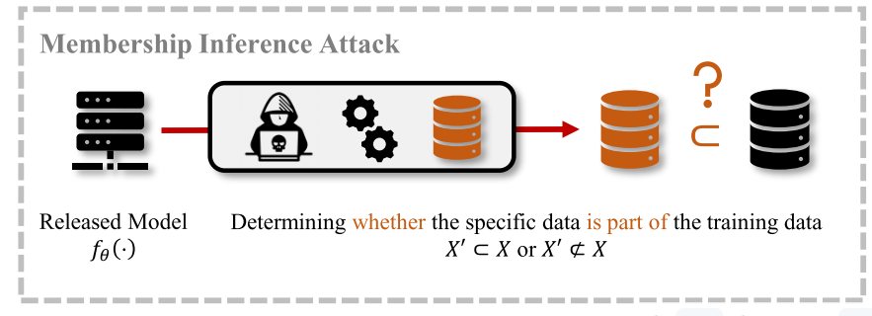
Figure 11. Membership Inference Attack. Source: Model Inversion Attacks: A Survey of Approaches and Countermeasure

To better illustrate the definition of Membership Inference Attacks, we introduce a typical learning process of an ML model. Figure 12 shows the typical learning process of a deep neural network (DNN) classifier. We use a learning algorithm A to train a predefined classifier f(x;θ) using the dataset D_{train} = {(x^{(n)} ,y^{(n)} )}^{N} _{n=1}. Once the training process is finished, the learned model f(x;θ∗) can be used to make predictions for unseen data. The definition of Membership Inference Attacks on ML models is as follows: Given an exact input x and access to the learned model f(x;θ∗), an attacker infers whether x ∈ D_{train} or not.

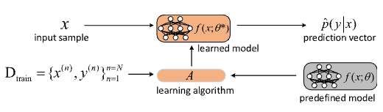
Figure 12. A typical deep learning process for classification models.Source: Membership Inference Attacks on Machine Learning: A Survey

Membership Inference Attack Approaches
Machine learning models such as DNNs are often overparameterized, which means that they have sufficient capacity to memorize information about their training dataset. Moreover, the training datasets are finite in size, and ML models are trained over multiple (often tens to hundreds) epochs on the same instances repeatedly. Consequently, ML models exhibit a different behavior on training data records (i.e., members) versus test data records (i.e., non-members), and also in the model’s parameters that store statistically correlated information about specific data records in their training dataset. For example, a classification model would classify a training data record to its true class with a high confidence score while classifying a test data record to its true class with a relatively small confidence. These different behaviors of ML models enable an attacker of Membership Inference Attacks to build attack models to distinguish members from non-members of the training dataset. Based on the construction of the attack model, there are two major types of Membership Inference Attack approaches, i.e., binary classifier-based attack approaches and metric-based attack approaches.

Binary Classifier-based Membership Inference Attacks
Essentially, a binary classifier based Membership Inference Attack involves training a binary classifier, which can distinguish a target model’s behavior of its training members from the non-members.

Metric-based Membership Inference Attacks
Unlike binary classifier-based Membership Inference Attacks relying on training a binary classifier to recognize the complex relationship between members and nonmembers, metric-based Membership Inference Attacks are more simple and less computational. Metric-based Membership Inference Attacks make membership inference decisions for data records by first calculating metrics on their prediction vectors. The calculated metrics are then compared with a preset threshold to decide the membership status of the data record.

Defenses against Membership Inference Attacks
The existing defenses against Membership Inference Attacks fall into four main categories, i.e., confidence score masking, regularization, knowledge distillation, and differential privacy.

Confidence Score Masking
Confidence score masking is mainly used to mitigate black-box Membership Inference Attacks on classification models. It aims to hide the true confidence scores returned by the target classifier and thus mitigates the effectiveness of Membership Inference Attacks.

Regularization
Regularization aims to reduce the overfitting degree of target models to mitigate Membership Inference Attacks. Therefore, regularization methods that can reduce the overfitting of ML models can be leveraged to defend against Membership Inference Attacks. Existing regularization methods include L2-norm regularization, dropout, data argumentation, model stacking, early stopping, label smoothing etc.

Knowledge Distillation
Knowledge distillation is used as a defense by transferring knowledge from a larger teacher model to a smaller student model. One method involves using an unlabeled dataset to train the teacher model, which labels the data. Low-entropy (easily classifiable) records from this labeled dataset are then used to train the student model, reducing the direct access of the private classifier to the original training data and minimizing membership information leakage.

Differential Privacy
By introducing noise during training, such as in the gradients or outputs, DP ensures that models do not memorize specific details about the training data, reducing the effectiveness of attacks. While DP can effectively limit the success of such attacks, it often comes with significant trade-offs, as strong privacy guarantees can lead to reduced model utility.

Model Extraction Attacks
The remarkable advances in machine learning technologies in recent years have spurred the expansion of Machine-Learning-as-a-Service (MLaaS) , which meets the increasing need for ML capabilities among users who might not possess the requisite expertise or infrastructure. MLaaS platforms offer publicly accessible APIs, enabling users to interface with backend ML models and systems seamlessly. Users are often charged on a per-query basis, making advanced ML capabilities both accessible and affordable.

However, there exists an inherent conflict between the proprietary nature of ML models and the public accessibility of MLaaS APIs, leading to a range of security concerns. One of the most prominent concerns is the threat of Model Extraction (ME) attacks. As illustrated in Figure 13, such attacks construct a piracy model functionally equivalent or similar to the backend model of MLaaS, via querying the black-box APIs with carefully crafted inputs.

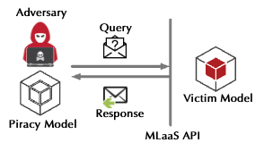
Figure 13. Model Extraction Attacks. Source: Model Extraction Attacks Revisited

Model Extraction Attack Approaches
According to the purpose of the attacker, we classify state-of-the-art attack schemes into two categories: model attribute extraction and model functionality extraction.

Model Attribute Extraction
Most existing extraction attacks focus on attribute stealing, including parameters, hyperparameters, architecture, and decision boundary, which are tightly related to the intellectual property rights of the cloud-based models. For instance, the StealML framework requires knowledge of both prediction labels and confidence scores and works with various popular cloud-based models such as logistic regression, support vector machine (SVM), decision tree, and shallow neural networks. In StealML, the attacker uses a set of crafted or publicly available data samples to query the cloud-based model and then uses the input-output pairs to construct a series of equations of parameters. By solving these equations, the adversary can infer the internal parameters of the targeted model.

Model Functionality Extraction
Apart from attribute extraction, another attack goal is to construct a substitute model that has similar performance to the targeted cloud-based model for the same tasks (i.e., functionality attacks). Stealing model functionality involves techniques to replicate the behavior of a target model using a substitute model. For simple models like Naive Bayes and SVM, their functionality can be extracted using more complex models, such as deep neural networks (DNNs). For sophisticated architectures, methods like KnockoffNets involve selecting a substitute model architecture, constructing a query dataset, and training the substitute model. Even when the exact architecture of the target model is unknown, using a sufficiently complex substitute model can effectively replicate the target's functionality, regardless of whether the two models belong to the same family.

Defences against Model Extraction Attacks

Defenses using Perturbations
Input and output perturbation-based defenses offer effective strategies for countering model extraction attacks. The core idea behind these methods is to introduce carefully controlled variations or obfuscations, making it significantly harder for adversaries to accurately infer or replicate the behavior of the target model.

Input perturbation-base defenses
Input perturbation defenses against model extraction attacks work by modifying the input queries sent to the target model, introducing variations that disrupt the adversary's ability to extract meaningful information. Two key approaches are linear interpolation defense and semantic interpolation defense. In the linear interpolation method, latent codes from user queries are combined to generate interpolated data points, introducing blended and unpredictable variations that obscure the connection between inputs and model outputs. On the other hand, semantic interpolation defense creates more interpretable modifications by leveraging semantic attributes like gender, age, or hair style for images, allowing for meaningful yet complex transformations of input data. These defenses increase the variability and complexity of the input queries, making it significantly harder for adversaries to map input-output relationships and reconstruct the target model’s decision boundaries, while still ensuring legitimate users can query the model effectively.

Output perturbation-base defenses
Instead of perturbing latent codes, these types of defenses directly perturb the generated samples. Output perturbation defenses against model extraction attacks work by modifying the responses provided by the target model to obscure its true behavior and limit the adversary’s ability to reconstruct it. These defenses directly alter the model’s outputs, introducing distortions while maintaining functionality for legitimate users. One method involves adding random noise to the outputs, subtly perturbing the predictions to reduce their accuracy. Adversarial noise can also be applied, intentionally skewing outputs to mislead the adversary while still appearing valid. Techniques like filtering, such as applying Gaussian filters, smooth the outputs to obscure fine-grained patterns that adversaries could exploit. Finally, compression methods, such as JPEG compression, degrade the quality of the outputs by removing subtle details, further complicating the adversary’s task.

Defenses using Queries Observation and Detection
Another approach to counter model stealing attacks is by detecting and preventing abnormal query patterns. This method works by analyzing the behavior of user queries and identifying deviations from expected norms. Normally, in a well-defined space, the distances between random data points follow a predictable distribution. However, queries made during model stealing attacks often involve deliberate modifications, leading to abnormal distance distributions. By performing statistical tests on query distances and examining feature distributions, it becomes possible to detect unusual activity and flag suspicious users. This proactive defense helps prevent malicious queries from compromising the model. PRADA for example is a generic technique that detects attacks against any cloud-based ML model. PRADA analyses the distribution of successive queries from a client and identifies deviations from a normal (Gaussian) distribution. If the distribution deviates beyond a set threshold, the system flags the activity as suspicious.

Adversarial Examples (a.k.a Evasion attacks)
Recent studies find that deep learning is vulnerable against well-designed input samples. These samples can easily fool a deep learning model with little perturbations imperceptible to humans.

Extensive deep learning based applications have been used or planned to be deployed in the physical world, especially in the safety-critical environments. In the meanwhile, recent studies show that adversarial examples can be applied to the real world. For instance, an adversary can construct physical adversarial examples and confuse autonomous vehicles by manipulating the stop sign in a traffic sign recognition system or removing the segmentation of pedestrians in an object recognition system.

In this phase the attackers can tamper only with the input data after the victim deep learning model is trained. Neither the trained model nor the training dataset can be modified. The adversaries may or may not have knowledge of trained models (architectures and parameters) but are not allowed to modify models, which is a common assumption for many online machine learning services.

Given a clean sample x with f(x) = y_{true} predicted by a trained model M. The attacker adds an imperceptible perturbation δ to x to create an adversarial example x′=x+δ, which is sufficient to mislead the model to produce a wrong output f(x) ! y_{true}, also known as untargeted attacks. In terms of targeted attack, it is to mislead the model to yield an attacker targeted class f (x) = y_{target} ! y_{true}.

For example, adversarial examples in an image classification task can be described as follows: Using a trained image classifier published by a third party, a user inputs one image to get the prediction of class label. Adversarial images are original clean images with small perturbations, often barely recognizable by humans. However, such perturbations misguide the image classifier. The user will get a response of an incorrect image label.

The adversary's attack capability is determined by how much information the attacker has about the model, including training data, feature sets, learning algorithms, and so on. Based on available knowledge by the attacker, attacks may be divided into three main groups: white-box, black-box, and grey-box.

White-box attack. The attacker has full knowledge about the target model, including the type of neural network model, the parameters , and so on. The adversary applies known knowledge to identify vulnerable feature spaces to facilitate the generation of adversarial examples. Usually, white-box attacks require computing the gradient with respect to the input, in order to craft the perturbation.

Black-box attacks. Contrary to white-box attacks, the adversary does not know any knowledge about the model but is allowed to analyze the vulnerability/weakness of the model by querying the AI system with carefully devised inputs and observing the outputs. Black-box attacks are more practical but more challenging to design.

Grey-box attacks. These attacks are also known as semi-white box attacks. The attacker needs to obtain partial knowledge of the model (except for the model parameters) to complete the attack on the target model.

White-Box Attacks
White-box attacks are methods designed to exploit neural network vulnerabilities by carefully crafting adversarial examples. These examples are imperceptible to humans but mislead models into incorrect classifications. Below are key attack strategies and their defining characteristics.

Optimization-Based Attacks
Early approaches involved complex optimization methods to generate adversarial examples. Solutions like L-BFGS approximate the minimal perturbation required to mislead a model while preserving the original image's visual similarity.

Gradient-Based Attacks
Fast Gradient Sign Method (FGSM): This attack efficiently generates adversarial examples during backpropagation. It is simple and suitable for large-scale adversarial data generation. Variants extend this method for both targeted and non-targeted attacks.

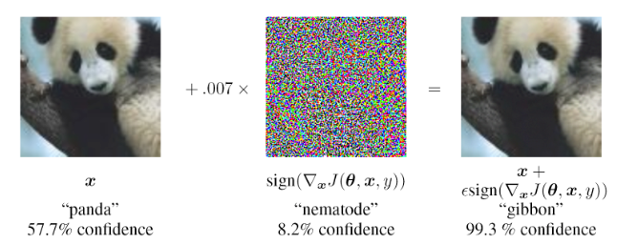
Figure 14. An adversarial image generated by Fast Gradient Sign Method:
left: a clean image of a panda; middle: the perturbation; right: one sample
adversarial image, classified as a gibbon. Source: Adversarial Examples: Attacks and Defenses for Deep Learning

Basic Iterative Method (BIM) and Projected Gradient Descent (PGD)
This method Iteratively finds the perturbation for each pixel point, ensuring tighter control over modifications. It is more precise but computationally heavier than FGSM, being its iterative (multi-step) version.

Saliency-Based Attacks
Jacobian Saliency Map Attack (JSMA): It focuses on perturbing the most influential pixels determined by a saliency map, reducing the overall alteration required to mislead the model. It has applications beyond images, including text and malware. A higher value of the saliency map indicates that the corresponding input features significantly influence the classification result.

Advanced Optimization Attacks

Minimal Adversarial Perturbations
The Carlini-Wagner Attack (CW) seeks minimal adversarial perturbation through a soft-constraint optimization problem that finds the trade-off between the size of perturbation (to minimize the distance between the adversarial and the original point) and the loss of the model (to make the sample misclassified).
The Decoupling Direction and Norm (DDN) and Fast-minimum Norm (FMN) attacks maximize the misclassification confidence within a variable-sized L-p constraint, with the objective of finding the minimum size for which the attack is successful.
All these methods iteratively improve the objective of the optimization problems with gradient-based techniques. In contrast with FGSM, BIM, and PGD, these seek the minimum adversarial perturbation, rather than the maximum loss achievable within a perturbation constraint.

Universal Perturbations
Universal Adversarial Perturbation (UAP): This attack produces a single perturbation applicable to multiple images, leading to misclassification across a dataset. It emphasizes generalizability rather than targeting individual samples.

Black-Box Attacks
Black-box attacks exploit models without requiring internal knowledge, such as gradients or parameters. These attacks often rely on alternative strategies like surrogate models, evolutionary algorithms, or optimization methods. Below are the main strategies and their defining features.

Adversarial Transformation Networks
ATN uses specialized neural networks to generate adversarial examples without gradient information. It can handle both targeted and non-targeted attacks and trains in either black-box or white-box settings.

Zero-Order Optimization
This attack estimates gradients indirectly to craft adversarial examples, avoiding direct access to model details. It supports both targeted and non-targeted attacks but is computationally expensive due to high query requirements.

Houdini
Houdini is a method that generates adversarial perturbations based on the gradient information of the network’s differentiable loss function, which can be tailored for the task loss. It is applied not only in image classification but also in speech recognition and semantic segmentation. Houdini can be used both as a non-targeted and targeted attack.

One Pixel
One Pixel requires only a small number of pixel points to be changed. Only one pixel point needs to be modified in an extreme case, and no information about the network parameters or gradients needs to make the attack. One Pixel Attack also applies to attack models where gradients are not differentiable or difficult to compute.

Adversarial Examples with Generative Models
Generative models, such as Generative Adversarial Networks (GANs) or Diffusion Models, provide powerful options for crafting adversarial samples. These models learn to replicate data distributions and can be leveraged to generate realistic adversarial inputs that effectively deceive target models. In adversarial contexts, generative models can be trained to produce perturbations or modified inputs that are indistinguishable from original data but lead to misclassification or misinterpretation by machine learning systems. By embedding the adversarial objectives within the generative process, these models can produce diverse and highly adaptive adversarial examples. For example, AdvGAN generates adversarial examples with a Generative Adversarial Network (GAN), which learns and approximates the distribution of original instances. For AdvGAN, once the generator is trained, it can generate perturbations efficiently. AdvGAN applies to both semi-whitebox (grey-box) attacks and black-box attack settings. In semi-whitebox attacks, there is no need to access the original target model after the generator is trained, in contrast to traditional white-box attacks. In black-box attacks, a distilled model is dynamically trained for the black-box model, and the generator is optimized accordingly.
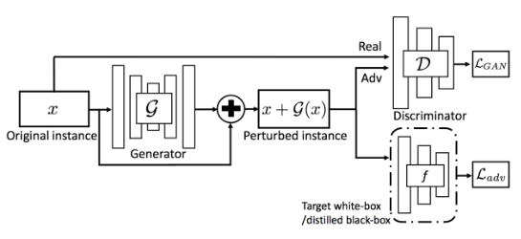
Figure 15. Overview of AdvGAN. Source: Generating Adversarial Examples with Adversarial Networks
In addition, Diffusion Models are a class of generative models that progressively transform random noise into realistic data samples through an iterative refinement process. By leveraging their ability to generate high-quality and diverse outputs, diffusion models can be adapted to craft adversarial samples by integrating adversarial objectives directly into the generation process. For instance, AdvDiff generates unrestricted adversarial examples, which are examples that are obtained by optimizing input noise vectors without any norm restrictions. Compared to traditional adversarial examples, unrestricted adversarial examples are more aggressive against current adversarial defenses. Compared with GAN models, diffusion models are more stable during training and provide better distribution coverage. Diffusion models contain two processes: a forward diffusion process and a reverse generation process. The forward diffusion process gradually adds Gaussian noise to the data and eventually transforms it into noise. The reverse generation process aims to recover the data from the noise by a denoising-like technique. A well-trained diffusion model is capable of generating images with random noise input. Similar to GAN models, diffusion models can achieve adversarial attacks by incorporating adversarial objectives. Experimental results on MNIST and ImageNet datasets demonstrate that AdvDiff is effective in generating unrestricted adversarial examples, which outperforms state-of-the-art unrestricted adversarial attack methods in terms of attack performance and generation quality.
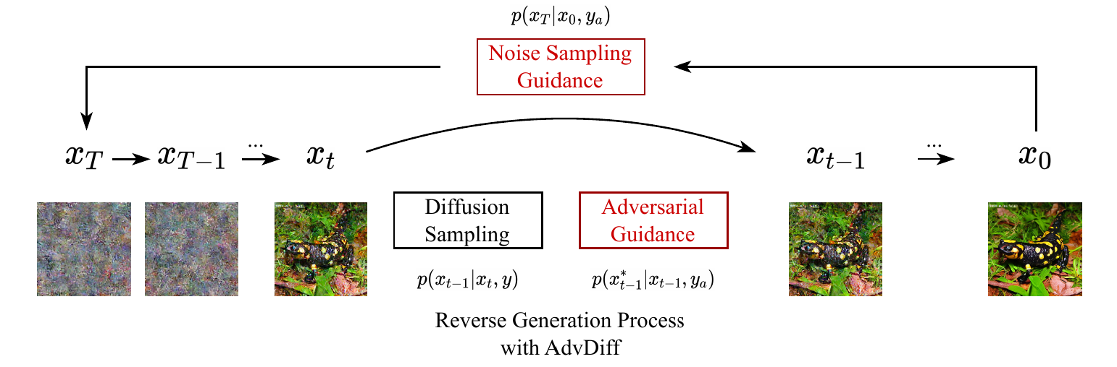
Figure 16: Techniques of AdvDiff to generate unrestricted adversarial examples. During the reverse generation process, the adversarial guidance is added at timestep x_{t} , which injects the adversarial objective y_{a} into the diffusion process. Source: AdvDiff: Generating Unrestricted Adversarial Examples using Diffusion Models

Defences against Adversarial Examples

Adversarial Training
Adversarial training is a defense method in which a model is retrained by injecting adversarial examples into the training set at every training iteration. In practice, one can generate adversarial examples using a method of choice such as the FGSM or BIM and add them in the training dataset in the training phase. It is found that this approach could defend well against white-box attacks but was not that effective in black-box scenarios.

Defensive Distillation
Defensive distillation is a defense method that works by training two networks, where one network (the “student”) is trained to approximate the other (the “teacher”). So, A large model (“teacher”) is trained using the original dataset and produces soft labels (probability distributions over classes). These soft labels capture richer class relationships than hard labels. Then, a smaller model (“student”) is trained using the soft labels generated by the teacher, instead of the original hard labels. This process transfers knowledge from the teacher to the student. By smoothing the decision boundaries, defensive distillation reduces the model's sensitivity to adversarial perturbations, making it harder for attacks to push inputs across these boundaries.

Gradient Regularization
Gradient regularization refers to adding constraints to the objective function during training to avoid significant changes in the model output with changes in the input. Typically, small perturbations do not significantly affect the output.

Feature Squeezing
There are two methods of data compression in the field of image classification: (i) Reduce the color depth and encode colors with lower values. (ii) Use the spatial smoothing filter, which allows multiple inputs to be mapped into a single value. Feature squeezing is a model-enhancing technology that reduces the representation data’s complexity by compressing the input features to resist adversarial perturbations.

Detectors
A detector is a mechanism that discriminates whether a detected image is an adversarial sample or not. Usually, the criteria for the detector to discriminate against the adversarial samples can be freely defined. The most straightforward approach is to label the adversarial and legitimate samples to train a classifier. There are two main types of classifier training methods. One approach is to train a classifier by directly labeling the adversarial examples and the original samples separately in the initial stage. Another way is to train a classifier by labeling the adversarial and clean samples only on a specific layer’s output values.

Data Randomization
The term data randomization refers to performing randomization technology to mitigate adversarial effects. Some approaches try to mitigate the adversarial effects by randomly resizing the images and using random padding technology to disrupt the structure of specific adversarial perturbations during the forward propagation phase of the model. Specifically, it consists of two steps. (i) Firstly, the input image is resized randomly. (ii) Then, zero random padding is applied around the resized image. The location of the padding is chosen randomly. Data randomization is effective in defending against both single-step attacks and iterative attacks. The data random defense method not only requires no additional training and is less computationally intensive but is also compatible with other adversarial defense methods.

Input Reconstruction Methods
Adversarial examples can be transformed to clean data via reconstruction. After the transformation, the adversarial examples will not affect the prediction of deep learning models.

PixelDefend
A defense mechanism that attempts to reconstruct adversarial images, so they align closely with the distribution of legitimate training data. It uses PixelCNN, a model trained on the training data, to adjust the pixel values of an adversarial image to make it more likely to belong to the training data's distribution. The amount of change made to the adversarial image is limited by a predefined threshold to ensure minimal alteration. Additionally, PixelDefend includes an adversarial detection step: if an input image is not detected as adversarial, no changes are applied to it, keeping the original image intact.

Defense-GAN
A defense mechanism leveraging the capabilities of Generative Adversarial Networks (GANs) to counter adversarial attacks. Unlike traditional methods, it does not alter the classifier’s structure or training process. Instead, it focuses on using a trained GAN to reconstruct input images, effectively reducing or eliminating adversarial perturbations. The GAN reconstructs the input to align it with the training data distribution, making adversarial examples less effective. However, for this approach to work effectively, it is crucial to train a stable GAN with carefully selected hyperparameters. Defense-GAN is applicable against both white-box and black-box attacks, making it a versatile choice for adversarial defense.
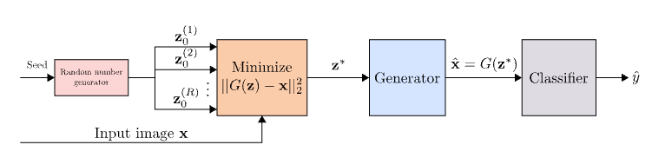
Figure 17. Overview of the Defense-GAN algorithm. Source: Defense-GAN: Protecting Classifiers Against Adversarial Attacks Using Generative Models

Integration Phase - System Integration Attacks
The security issues appear to be more complex when AI is integrated into real-world applications. The security issues are different for different application scenarios, and we should take a global view of the security of AI. In this subsection, several security risks in the actual integration phase are explored.

AI confidentiality
Confidentiality of AI includes data confidentiality and model confidentiality. Confidentiality of AI is generally explicitly related to model privacy, though it can also (indirectly) result in security issues, such as model inversion and model extraction.

Model inversion and model extraction are two significant threats in the realm of machine learning, particularly concerning the privacy of sensitive data used in training models. Model inversion refers to the ability of an adversary to reconstruct input data from the model's outputs, effectively revealing private information about the training dataset. This is particularly concerning in scenarios where models are trained on sensitive data, such as medical records or personal information. On the other hand, model extraction, for another, is generally understood to mean executing an acceptable number of queries through an API and observing the output results (probabilities or labels) to infer model parameters or extract an approximate model that closely matches the target model.

To mitigate these risks, several approaches have been proposed, including Differential Privacy (DP), Homomorphic Encryption (HE), and model watermarking techniques. Differential Privacy provides a mathematical framework that ensures that the output of a model does not significantly reveal information about any individual data point in the training set. By adding noise to the data or the model's outputs, DP helps to obscure the contributions of individual records, thereby protecting user privacy. Homomorphic Encryption, on the other hand, allows computations to be performed on encrypted data without needing to decrypt it first. This means that sensitive data can remain confidential even while being processed, significantly reducing the risk of exposure during model training and inference. Furthermore, watermarking techniques can be employed to embed unique identifiers within the model, which can help in tracing unauthorized copies and ensuring accountability.

Code vulnerability protection
Current AI system technologies (e.g., deep learning) are built on frameworks (e.g., Tensorflow, Caffe, and Torch). These frameworks rely on a variety of base libraries and third-party components that have greatly facilitated the development of AI technologies. However, they are not designed to be flawless and have vulnerabilities. More concretely, recent studies have shown that unaudited third-party code snippets—the code response for loss computation—can implant backdoor into the deep learning model. Although code vulnerabilities are part of the model implementation process, they are also a critical part of the security deployment of AI systems.

Model Tampering Attacks
Note: This attack also occurs during the training/inference phase.

Model tampering attacks involve malicious alterations to a model's weights or structure, compromising its performance if the attacker gains access.

Model tampering typically occurs in the integration phase, where attacks may degrade performance or cause incorrect results. Security measures are crucial to mitigate these risks.
A model tampering attack involves an adversary directly modifying a machine-learning model’s parameters, architecture, or associated metadata so that it behaves in unauthorized or unexpected ways. This can include:

- Altering the model’s weights so that predictions are skewed toward a desired outcome.
- Embedding hidden functionality (e.g., backdoors) by modifying certain layers or adding malicious sub-networks.
- Injecting or removing specific features that compromise the model’s performance or trustworthiness.

Model tampering most commonly occurs during or after the integration phase.

In the training phase, tampering typically involves data poisoning or label manipulation rather than directly altering the trained model file. If the attacker controls the training environment, they can indeed tamper with the model as it is trained, but this is more often referred to as a poisoning attack unless they directly hack the model artifacts.

At inference time, attackers usually perform adversarial example attacks (feeding specially crafted inputs to mislead the model) rather than modifying the model itself.

After a model is trained and prior to—or during—its deployment, attackers with access to the model file (or the environment hosting the model) can tamper with the parameters, layers, or logic.
This is typically considered a model tampering attack if they physically change the underlying code or model checkpoint.

Denial of Service Attacks
In the integration phase of an AI system, the potential for Denial of Service (DoS) adversarial attacks poses significant risks. These attacks can disrupt the functionality of AI applications by overwhelming them with malicious requests or by exploiting vulnerabilities in the system's architecture. This phase is critical as it involves the deployment of AI components and models into operational environments where they interact with other systems and users, making them susceptible to various forms of adversarial manipulation.

The interconnected nature of these components introduces new attack surfaces, where compromising a single element can create a cascading effect, disrupting the performance of the entire system. This highlights the importance of implementing robust security measures to safeguard the AI infrastructure during this phase.

Table Summary
Single Model Paradigm
Phases | Attacks
Data Collection | - Data Bias  - Fake Data  - Data Breach  - Sensor Spoofing Attack
Data Pre-processing | - Data Leakage  - Scaling Attacks  - Image Scaling Attacks
Training | - Availability Poisoning Attacks  - Integrity Poisoning Attacks  - Backdoor (Integrity) Poisoning Attacks
Inference | - Model Inversion Attacks  - Membership Inference Attacks  - Model Extraction Attacks  - Adversarial Examples

Collaborative model paradigm

Overview
Federated learning (FL) is poised to become a cornerstone technology in the near future, driven by its potential to address critical challenges in data privacy, scalability, and efficiency. As data privacy concerns continue to grow, FL offers a compelling solution by enabling machine learning (ML) models to be trained on decentralized data sources without the need for data to be centralized. Instead of pooling all data in one central location, the learning process occurs on individual devices or servers where the data is originally generated or stored. This approach not only safeguards individual privacy by minimizing the risks associated with centralized data storage but also aligns with stringent data protection regulations like the GDPR, making it a preferred approach for companies and organizations handling sensitive data in today's data-centric landscape.
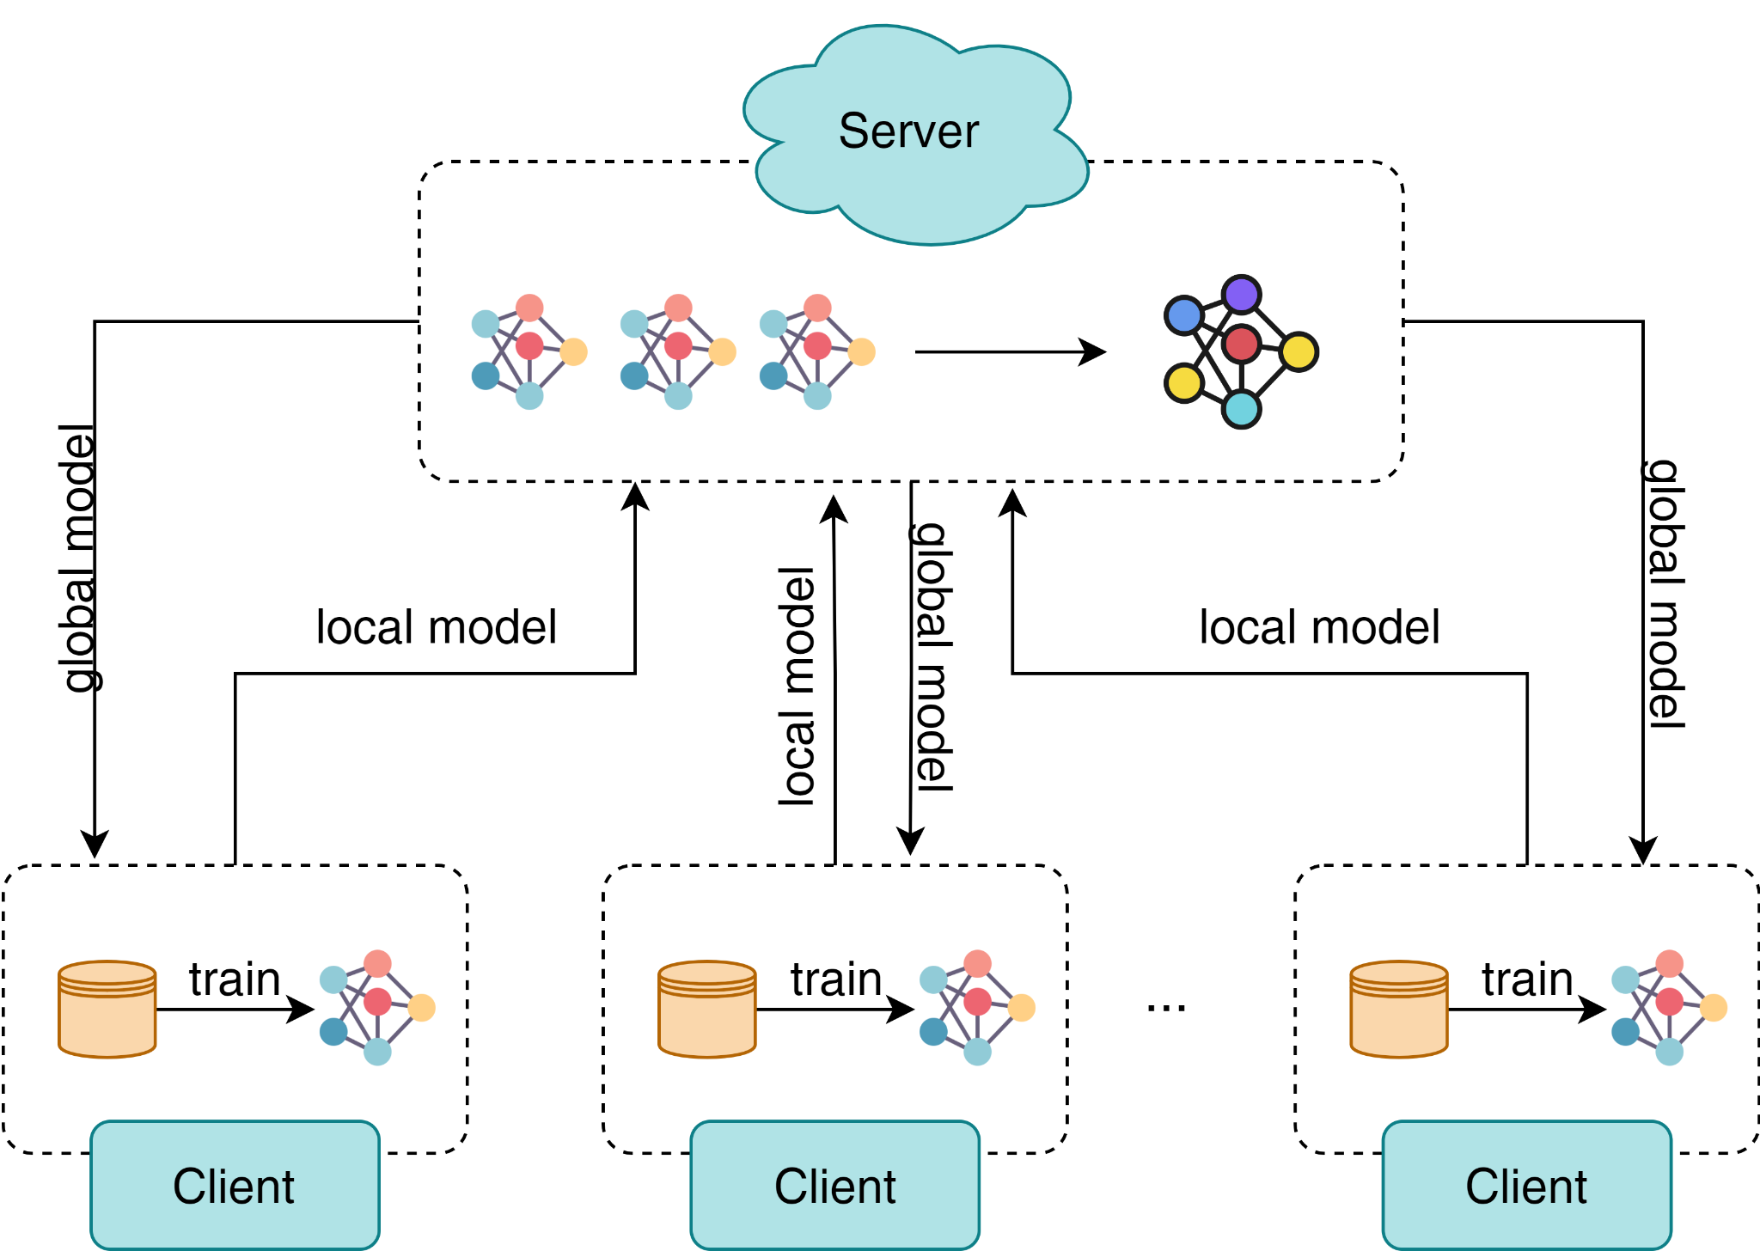
Figure 18. The Federated Learning concept

Furthermore, FL's potential to scale and distribute ML across a vast number of devices and edge computing environments aligns with the growing trend of edge AI and the Internet of Things (IoT). As more devices become capable of running ML models locally, FL allows for the collaborative training of these models without the need for continuous data transmission to a central server, thereby reducing latency and bandwidth constraints. This potentially alleviates communication costs, which in return enhances the scalability of edge networks, presenting a significant advantage in scenarios where real-time processing and responsiveness are paramount.

Despite mitigating the risk of sensitive data leakage inherent in direct data sharing, the widespread adoption of FL introduces novel cybersecurity risks that industries and applications must address. One key concern is the potential for data and model poisoning attacks. Since FL relies on models being trained across various decentralized devices or servers, malicious actors could attempt to inject poisoned data into the training process. This data manipulation can subtly compromise the integrity of the global model, leading to biased, erroneous, or even malicious model updates. Additionally, model poisoning is a more potent and impactful attack within the context of FL. In this type of attack, the adversary changes the parameters of the target model directly. These alterations can manifest in the form of errors in the global model's predictions, potentially leading to incorrect or unreliable outcomes. By targeting the parameters directly, the attacker can potentially exert a more influential and nuanced impact on the final model, as opposed to trying to manipulate the individual data points. Moreover, model poisoning attacks may even introduce a backdoor into the model, allowing the attackers to exploit the model for their own gains. To counter this, robust security measures and anomaly detection mechanisms must be put in place to identify and mitigate these threats.

Another security challenge is the risk of model inference attacks. Even without direct access to the decentralized data sources, attackers can exploit the information leaked by model updates to infer sensitive data about individuals or organizations. These attacks range from membership inference, which seeks to discern if a specific data point contributed to the model's training, to model inversion, where adversaries attempt to reconstruct training data or infer underlying data distributions. Furthermore, model stealing attacks attempt to create a surrogate model that closely approximates the global model by querying it and using the responses to reconstruct a similar local model. The more rounds of FL occur, the more information an attacker can glean, potentially piecing together sensitive or confidential information over time. Protecting against these risks requires careful consideration of privacy-preserving techniques, such as differential privacy, output perturbation and secure multi-party computation, to obscure the information contained in model updates. As FL becomes more prevalent, industries must invest in robust cybersecurity measures and privacy-enhancing technologies to safeguard their data and models against these emerging threats.

Classification of federated learning
The datasets involved in model training are generally composed of data feature spaces, sample spaces, and data label spaces owned by different users. FL can be divided into horizontal federated learning (HFL), vertical federated learning (VFL), and federated transfer learning (FTL), based on the distribution of the data feature and sample spaces among different users.

- HFL refers to the FL setting where participants share the same feature space while holding different samples. For example, Google uses HFL to allow mobile phone users to use their dataset to collaboratively train a next-word prediction mode. Another example, several hospitals may each store similar types of data (e.g., demographic, clinical, and genomics) about different patients.
- VFL refers to the FL setting where datasets share the same samples/users while holding different features. For example, Webank uses VFL to collaborate with an invoice agency to build financial risk models for their enterprise customers
- FTL refers to the FL setting where datasets differ in both feature and sample spaces with limited overlaps. For example, EEG data from multiple subjects with heterogeneous distributions collaboratively build BCI models using FTL

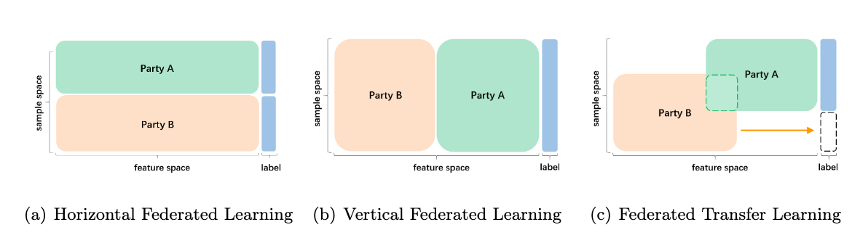
Figure 19. Three categories of Federated Learning

Threat models of FL
Although the original intention of FL is to prevent data sharing from achieving strict privacy protection, there are still privacy and security issues. Regarding security, the weakness of FL lies in adversarial attacks, and relevant models have a high probability of two problems occurring at the beginning of the design phase: First, due to the principle of the model, the server often observes the updates for each user. If it is malicious, it can easily tamper with the training process and control the user’s global parameters, affecting the update of the final model. Second, during FL work, users can join or quit freely. Therefore, malicious users can use this chance to observe the global parameters, steal user information, or destroy the global model. In both passive and active attack scenarios, the primary purpose of the attacker is to destroy the basic properties of the learning model, mainly in the aspects of confidentiality, integrity, and availability.

In terms of security, attacks are often focused on integrity and availability. Threats to integrity and availability mainly focus on the output of the machine learning model, which can seriously affect the regular use of the model. An integrity threat indicates the attacker inducing the model to behave such that the model output is the specified classification label during the prediction process. Usability threats mainly prevent the user from obtaining the correct output of the model or interfere with the user to obtain some model features, such that the user-acquired models are no longer reliable.

In terms of privacy, attackers tend to focus on confidentiality. For confidentiality, attackers can expose the target model information and the prediction results. According to existing research, privacy-preserving algorithms can still put user privacy at risk. During the training process, malicious clients can often infer the exact data points in the training set, such as a specific location. At the same time, the malicious customer can also study how to infer attributes from participating customer data, leading to the leakage of sensitive information. Furthermore, they may also deliberately reveal private data to third parties or even take advantage of a small part of the information which belongs to the user’s original gradient to reveal the local data.

Insider vs. Outsider
One of the key elements of any distributed system is the communication between different parts. Communication is very vulnerable, since it can be compromised by agents from outside the learning system, which are known as outsider attackers. When the attack is carried out by one of the participants in the distributed system, either one or more clients, or the server, it is known as an insider attacker. Clearly, the scope of the two attacks is very different: insider attacks are more harmful and may be aimed at modifying the behaviour of the model or inferring valuable information from other clients, while those carried out by outsiders are usually aimed only at inferring information about the data or the resulting learning model.
Outsider attacks mainly focus on sniffing information of the communication channels between the agents involved. They are either side-channel attacks, when the attacker gains information from the implementation of the FL scenario, or man-in-the-middle attacks, when the attacker intercepts the communication channel by disguising herself as the receiver part. Both attacks are related to the protocols used to establish communication and their implementation.
Insider attacks can be divided into two types:
Byzantine attacks. They consist in sending arbitrary updates to the server, so it compromises the performance of the global learning model.
Sybil attacks. They consist of collaborative attacks, either by several attackers joining together or by simulating fictitious clients in order to be more disruptive.

Client vs. Server
The main point of difference lies in the amount of information available. While the attacks carried out by clients only have information of one or several clients, the server holds information about the model architecture and the updates of the clients in each round of learning. Even in cryptographic implementations of the federated communication among the federated server and the clients, the server owns more information than the clients, as it is the only one with enough knowledge to decipher the models.

Attacker capabilities
In centralized settings, the white-box attacker has full access to the target model, including the model architecture, the parameters and its internal state. In contrast, the black-box attacker does not have any access to the target model and additionally, he/she might have some additional information about the architecture of the target model or its training procedure. These two classifications of attacker knowledge are too general to represent every type of attacker, because there is no middle ground to consider attackers whose knowledge in the black box setup is too restricted, and in the white box setup is not sufficiently constrained. To address this issue, a grey-box attacker was introduced, which is a black-box attacker with some specific statistical knowledge not publicly available that concerns her victim. This description of attacker knowledge is tailored for a centralized learning setting, and as a consequence it does not fit other learning settings as the attack surface changes. In a FL system, white-box, grey-box or black-box attackers can be any node, either the clients or the server. Moreover, the exposed attack surface is greater than in centralized settings.

Honest‑but‑curious vs. malicious
A malicious (or active) attacker tries to interfere in the training process of the learning model with the aim of corrupting the target model, for example, damaging its performance or injecting a secondary task. On the contrary, an honest-but-curious (or passive) attacker does not interfere in the training process and follows the federated learning protocols but tries to obtain private information about other clients from the received information.

Collusion vs. No-collusion
The collusion threat lies in the fact that the attacker who controls more clients has more power in a distributed system. There are two collusion types: (1) server-participants, in which the attacker controls some benign participants and the server, and it aims to infer information about the rest of the clients; and (2) participant-participant, in which the attacker controls a fraction of the benign clients and aims to infer information about benign clients, the server or to harm the learning model.

Training phase vs. Inference phase (training-time vs. inference time)
The training phase is generally attacked in a way that attempts to affect or compromise the FL model itself. During the training phase, an attacker can use a data poisoning attack to compromise the integrity of the training dataset collection or run a model poisoning attack to achieve the same effect. An attacker can also launch a series of inferential attacks on a single participant’s updates or a collection of updates from all the participants.
Attacks in the inference phase are called evasion/exploratory attacks. They usually do not tamper with the target model but instead, cause the model to produce an incorrect output (target/non-target) or gather evidence about the characteristics of the model. Suppose an attacker has full access to an FL model (i.e., a white-box attack), and the target model is deployed as a server. In that case, the maintained model is not only subject to the same evasion attacks as a typical machine learning setup, but its unique model broadcast step allows any malicious client to access the model.

Security Attacks

Untargeted/Non-directed Attacks
In the context of FL, an undirected attack refers to an attacker’s objective of causing damage or disruption to the entire federated learning system, without specifically targeting a particular model, participant, or task. The aim of such attacks is to undermine the overall security and reliability of federated learning. Attackers employ various methods to achieve their goals, including tampering with or injecting malicious data to disrupt participants’ training processes and modifying participant models to degrade the overall performance of the federated model.

Byzantine Attacks
A Byzantine attack in federated learning refers to the intentional malicious actions taken by attackers to undermine the security and reliability of the federated learning system. These actions involve sending false, incorrect, or intrusive data, model parameters, or aggregation gradient updates during the training phase. These updates can mislead the aggregation process, degrade the global model's performance, or even introduce vulnerabilities.

Targeted/Directed Attacks
Directed attack in federated learning refers to a malicious attack specifically targeted at particular participants or tasks, with the intention of interfering, destroying, or manipulating the performance of the model training process or the models of specific participants. In contrast to undirected attacks, targeted attacks are more focused and specific, where attackers have clear goals or motives and employ tailored measures to disrupt specific participants or tasks.

Poisoning Attack
A poisoning attack is an attempt by an attacker in FL to corrupt the overall model generation by inserting "toxic" data into the model during the training phase. Specifically, an attacker can modify or delete their original training data, resulting in an absence of the original data distribution, or replace it with the original data, disrupting the functional implementation of the model. Depending on which part of the client’s information is poisoned, we differentiate between data-poisoning and model-poisoning attacks, and we refer to both attacks as poisoning attacks.

Data Poisoning
The attacker is assumed to have access to the training data of one or more clients and to be able to modify it. When we consider the extent to which the attacker has attacked the data labels and the amount of training data poisoned, there are two categories:
- Clean-label: assumes that the adversary cannot change the label of any training data, that the data is certified as the correct class by a specific process, and that the poisoning of the data sample must be undetectable.
- Dirty-label: In a dirty-label poisoning attack, the adversary can introduce a large number of data samples that it wishes to escape classification into the training set along with the desired target labels. Classical dirty-label approaches include label-flipping attacks, sample poisoning attacks, and out-of-distribution attacks.

Label-flipping
This attack consists of modifying the labels of a portion of the training data and embedding pre-prepared attack points. It can be either targeted, by exchanging some specific labels, or untargeted, by random label shuffling.

Samples poisoning attack
Unlike label-flipping, this attack consists of modifying part of the training data samples. The poisoning can be of different types, such as including patterns in the samples and associating them with some target class or normalizing the samples and adding uniform noise with the aim of impairing the performance of the model.

Out-of-distribution attack
This attack is similar to the poisoning samples attacks, although they differ in that the poisoned training samples are not modifications of the original ones, but samples from outside the input distribution.

The goal of most data-poisoning attacks is to impair the global model and thus the local models of all clients. However, it is also possible that the goal of the attackers is not to impair the local models, but only a specific subset of them. Therefore, we can distinguish three types of data poisoning attacks, based on the attacker’s level of access to the target node, as follows:
- Direct threat: The attacker injects a poisoned sample directly into the target node.
- Indirect threat: When the attacker cannot access the target node, it may poison the target node by training its local model with poisoned samples to be added to the global model.
- Hybrid threat: This involves the flexible use of the first two types of attack.

Model Poisoning
These attacks consist of directly poisoning the model updates sent by the clients to the server. Although data-poisoning attacks naturally lead to model-poisoning attacks, here we focus only on those attacks that directly modify the local update weights, thus altering the final generated model.

Random weight generation
These attacks are based on generating the model weights as a vector of randomly generated values of the same dimension as the model weights received from the server.
Two specific examples are:
- random weights attack: an interval [-R,R] is inferred from the global learning model and the weights randomly generated in that interval
- Gaussian attack: a white-box attack, which chooses as model weights a sample from the Gaussian distribution resulting of the other clients’ model updates.

Information leakage
A particular use case of model-poisoning attacks in FL is information leakage, where the objective is not to compromise the global model, but the communication among the attackers through a secure protocol. In this manner, certain clients are coordinated in such a way that they know common rules and by modifying small parts of the model weights they can communicate.

Backdoor attacks
Backdoors are hidden patterns trained into deep neural network models, which produce unexpected behaviours that cannot be detected unless the input of some trigger activates them.
A backdoor attack is a specific form of model poisoning where an attacker aims to implant a "hidden trigger" or backdoor into the global model. The key idea is to make the global model behave normally on most inputs but exhibit specific, attacker-chosen behaviors when exposed to inputs containing the trigger.

Backdoor attack can be divided into the following two categories:
- Semantic backdoor attacks: can cause the model to produce incorrect outputs from unmodified numeric inputs as the attacker expects (e.g., all cats are incorrectly classified as birds). The attacker is free to choose natural features that occur in the real world (e.g., random colours) or features that cannot occur without the attacker’s involvement (e.g., an item only the attacker possesses). The attacker can choose whether the backdoor is triggered by a specific scenario in which no attacker is involved, or only by a scenario that the attacker physically modifies. Both types of semantic backdoor do not require the attacker to modify the digital image during testing.
- Pixel pattern backdoor attacks: requires the attacker to modify the digital image’s pixels, especially during testing, such the model misclassifies the modified image. However, the attacker is required to poison the model during training and modify the inputs during testing.

Summary
Both data poisoning attacks and model poisoning attacks are ways to modify the client’s local model. However, model poisoning attacks tend to work better in practice because they can directly modify local model parameters. For example, the experimental results showed that in a given scenario, an attacker controlling 1% of clients to perform a model poisoning attack could achieve the same (or even better) effect as controlling 20% of clients to perform a data poisoning attack. However, data poisoning attacks also have their advantages. For example, data poisoning attacks are more intuitive, and attackers can implement label flipping according to their intentions. Moreover, attackers can often combine data poisoning attacks with model poisoning attacks. For example, the label-flipping strategy is first used to train the poisoned model, and then the model poisoning attack is used to maximize the effect of the attack.

Privacy Attacks
Privacy attacks are designed to disclose information about the participants of a machine learning task. These not only pose a threat to the privacy of the data used to train the machine learning models, they also pose a privacy risk to those people who agreed to share their private data. FL was thought of as a privacy preserving distributed machine learning paradigm, however the learning process exposes a broad attack surface. While the private data never leaves their owner, the exchanged models are prone to memorization of the private training dataset.

Membership Inference Attacks
The main objective of these attacks is to determine whether the provided data was used to train the victim model given a client’s model and some data. It infers whether a specific sample is a member of the model’s training set by analyzing the model’s output or accessing the probability distribution of the model.

Given a training dataset D and a classification model Ft trained on D, a machine learning service provider can offer classification services through a prediction API. This API gives the user black-box access to the model Ft. Users can use their data to send prediction queries to the service and receive classification predictions. The adversary can use such a service to gather information about the private data set D, in order to predict whether the model Ft was trained privately on that dataset. At the same time, the adversary then constructs a member inference attack model for deployment, using any public or background knowledge of the training dataset D or the target model Ft, in order to launch a member inference attack in real-time.

Member inference attacks are typically performed during the model training phase in an FL environment. This attack involves determining whether a single data record is in the training data set. Suppose the training data is private or sensitive. In this case, the attacker’s ability to infer the presence or absence of a particular record in the input data training poses a direct privacy threat. Many researchers have elaborated on such attacks from different perspectives.

Gradient Ascent
It consists in nullifying the effect of the gradient descent on the instances used to test the attack. As a result, it broadens the difference between the data points used to train the victim model and the data points not used to train the victim model.

Client Isolation
The objective of this technique is overfitting the victim model by not sharing the global learning model with the victim client, that is, isolating the victim client from any update. Overfitting makes the victim model retain more information about its training dataset.

GAN-based attacks
GANs aim to generate similar samples with the same distribution as the samples in the training data. It is important to emphasize here that GANs generate these samples without the original samples and can be applied to member inference attacks by learning the distribution of the data through deep neural networks.

Model Inversion Attacks
In the FL setting, the models are constantly updated via queries and model updates from multiple devices. Attackers can easily rebuild the model in case they get hold of these queries. This type of attack is discussed in ‘‘equation solving attacks’’. In such attacks, the adversary can understand the data used in training as well as models. Model inversion attacks basically do the reconstruction of training data from model parameters (in White-box setting).

Deep leakage from gradient attacks
In DLG attacks, it is assumed that the server is malicious, and its objective is to reconstruct the participant’s data by making use of their uploaded gradient. The reconstructed data is optimized by the server to minimize the Euclidean distance between raw gradients and the ones created during the backpropagation of the reconstructed data.

Gradient similarity attacks
In GS attacks, the idea will be similar to DLG attacks. Rather than Euclidean distance, GS attacks make use of cosine similarity between raw gradients and the synthetic gradients for optimization of reconstructed data through local updates.

Feature Inference Attacks (Reconstruction or Gradient Inversion Attacks)
This type of attack aims to recover a client’s dataset in the federated learning task. Usually, the recovered data are images or plain text. This attack is often referred to as a reconstruction attack in HFL. In contrast, in a VFL environment, the attack aims to extract private features owned by both parties. Feature inference attacks can be classified into two categories, based on the information exchanged between the client and the federated server.

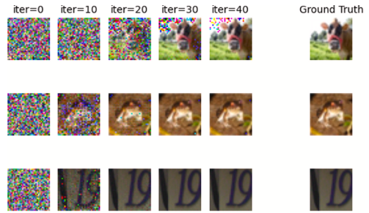
Figure 20. Gradient based Feature inference attack. Source: Deep Leakage from Gradients

Gradient-based Attacks
Selected clients share their gradients with the federated server in the communication rounds, that is, a federated SGD (Stochastic Gradient Descent) based training procedure. Therefore, the attack surface is the clients’ gradients.

Parameter-based Attacks
The selected client shares its local model parameters with the FL server during the communication round. Therefore, the attack surface is the client’s parameters, focusing only on reconstructing the training images. In this field, using GANs for constructive attacks has become a key endeavour for many research teams.

Label-inference Attacks
An attack method based on output labels, where attackers infer important features used by a model by observing its output labels. In this process, attackers do not need direct access to gradient information but instead make inferences by inputting different samples and observing their corresponding output labels. For example, in a vertically federated learning scenario where medical data is jointly trained, let’s assume one participant possesses patient medical record features, while another participant has the corresponding diagnostic labels. When the model predicts and outputs labels based on the feature data, attackers can infer patients’ diagnostic results by observing the output labels and subsequently gain access to sensitive medical information.

Property Inference Attacks (Attribute Inference Attacks)
This kind of attacks, which are also known as attribute inference attacks, aims at extracting whether a property of a client or a property of the population of participants in a FL task, which might be uncorrelated with the main task of the machine learning model, is present in the FL model. In other words, the aim is to infer some property of an individual or the population which is not expected to be shared.
An example of inferring an uncorrelated property is the following: consider a machine learning model whose objective is to detect faces, then the objective of the attack is inferring whether there are training images with blue-eyed faces. As stated, we can categorize these attacks according to the target of the attacker.

Population distribution
The attacker attempts to infer the distribution of a function within a federated user-side group. Attackers can infer the proportion of each label in a round of communication. However, this attack requires both client-side knowledge and partial server-side knowledge (i.e., the approximate number of the users selected by the server in a training round, the average number of tags held by each participant, and the number of data samples for each tag).

Individual distribution
The attacker’s goal is to reveal whether the target client has attributes that may not be relevant to the main FL task.

Defences against Security and Privacy Attacks
While adversarial attacks can be split into disjoint categories, the same is not true for their defences as some of them are effective for more than one type of attack category. Consequently, instead of grouping defences according to the attack defended, we categorize them into three main groups according to the federated scheme they are implemented in: server, client and communication channel.

Server Defences
The federated server is usually assumed to be reliable, because it is a controlled and accessible federated element by FL experts, in contrast to clients that are independent and inaccessible elements. Accordingly, most defence mechanisms are implemented on the federated server. Within this type of defences, we present the following taxonomy. Note that some defences may combine characteristics of two categories of taxonomy. In this taxonomy, we have classified the defences according to the category that we consider best represents them.

Robust aggregation operators
The first and most common approach to defend against poisoning attacks to the federated model is to use estimators that are statistically more robust than the mean to outliers or extreme values. Some aggregation operators, such as FedAvg, are susceptible to outliers. For that reason, many aggregation operators based on more robust estimators
have been proposed. We highlight the following ones:
- Median: is a robust-aggregation operator based on replacing the arithmetic mean by the median of the model updates, which choose the value that represents the centre of the distribution.
- Trimmed-mean: Is a version of the arithmetic mean, consisting of filtering a fixed percentage k-% of extreme values both below and above the data distribution.
- Krum and Multikrum: This aggregation operator is designed ad-hoc to prevent attacks to the federated model, so it is based on filtering out the model updates of the clients which present an extreme behaviour. For that, it sorts the clients according to the geometric distances of their model updates distributions and chooses the one closest to the majority as the aggregated model. Multikrum incorporates a 𝑑 parameter, which specifies the number of clients to be aggregated (the first 𝑑 after being sorted) resulting in the aggregated model.
- Gradient clipping: In a typical gradient clipping approach, we can set a threshold for the model parameters and discard all parameters that exceed the threshold.
- Adaptive Federated Averaging (AFA): Proposal of a defence mechanism against Byzantine attacks based on the weighting of each client using a Hidden Markov model by means of the cosine similarity to measure the quality of model updates during training. The authors report that it discards both poor and malicious clients, improving computational and communication efficiency.

Anomaly detection
These defence methods consist in identifying adversarial clients as anomalous data in the distribution of local model updates and removing them from the aggregation. For this purpose, multivariate or adaptations of univariate anomaly detection machine learning techniques are applied.

Differential privacy
Even though privacy is a topic out of the scope of adversarial attacks to the federated model, DP has been proven to be a viable defence method against these attacks. However, it is also known that DP greatly deceives the performance of the model under circumstances of data imbalance, which is expected to happen in most federated scenarios. Applying DP to the aggregation operator overcomes it to some extent.
- DP-FedAvg, also known as Central DP, is a differentially private aggregation operator which stems from the FedAvg operator. It shares some ideas with the robust-aggregation operators, given that it removes extreme values by clipping the norm of the model updates, like the Norm thresholding operator, and then adds Gaussian noise calibrated to the clip. To provide guarantees of (𝜖,𝛿)-DP, the order of Gaussian noise required is high enough to significantly reduce accuracy of the federated task.
- Weak DP, which shares the same aggregation procedure, but it does not guarantee (𝜖,𝛿)-DP nor any known privacy preserving property. It adds sufficient Gaussian noise to defeat the adversarial attack and preserve the accuracy of the federated task.

Less is more
Another defence approach in the literature against adversarial attacks to the federated model is based on the fact that original task knowledge will be located in most of the weights in the model, while the weights affected by poisoning attacks will be a small portion of them.
- Post-training defence: consists of pruning the resulting global model in order to protect it against attacks that may have taken place during training. Specifically, the authors design a federated pruning method to remove redundant neurons from the neural network and to adjust the outliers of the model. They propose two pruning approaches based on majority vote and ranking vote.

Client Defences
Server defences assume that the federated server is trusted as a data collector and aggregator. However, this assumption might be too strong, therefore there is a requirement for defences when the assumption of a trusted server is removed. In such a situation, defences at client level must be deployed and as a consequence, at least a portion of the clients is supposed to be benign. In contrast to server-side protection, which protects clients as a whole, client-side defences are thought to be strongest as they provide protection for each client individually.

Differential Privacy
Generally, these defences are designed to defend against server-side privacy attacks, although some may protect clients from adversarial attacks.

Homomorphic encryption
HE enables computations on encrypted gradients or model updates, ensuring that the raw data or gradients are never exposed to the server or other clients. This protects against gradient inversion attacks, where adversaries attempt to reconstruct private training data from shared gradients, and eavesdropping, where attackers intercept updates during transmission. Since all computations occur on encrypted data, even if the server is compromised, it cannot access sensitive client information. Additionally, HE safeguards against certain poisoning attacks by preventing adversaries from tampering with gradients directly, as the encrypted updates cannot be maliciously altered without detection.

Cluster-based methods
Cluster-based methods analyze the clustering structure of training data to detect and exclude malicious samples. These methods partition the training data into distinct clusters and subsequently identify abnormal or inconsistent sample groups to eliminate malicious samples. The approach relies on the similarity and clustering structure among samples, assuming that there are discernible differences between malicious and normal samples in the feature space. By leveraging these differences, cluster-based defense strategies effectively mitigate the impact of security attacks in federated learning.

Adversarial training
Adversarial training is the most widespread approach to preventing attacks against federation models. Adversarial training is a defense mechanism designed to make the global model robust against adversarial attacks by incorporating adversarial examples during the training process. This technique trains the model to recognize and correctly classify both clean and adversarially perturbed inputs, enhancing its resilience to malicious manipulations.

Perturbation methods
These are an alternative approach to provide defenses against privacy attacks that are not based on DP. Its main aim is to introduce noise to the most vulnerable components of the federated model, such as shared model parameters or the local dataset of each client, to reduce the amount of information an attacker can extract.

Gradient compression
Prunes gradients which are below a threshold magnitude.

Random Sketching
A dimensionality reduction technique used to compress gradients or updates shared between clients and the central server. It involves projecting high-dimensional data (e.g., gradients) into a lower-dimensional space using a randomized transformation, such as multiplication with a sparse or structured random matrix. This helps reduce communication overhead while preserving essential information for model training.

Communication channel defences
These defences cover the space of secure implementations of FL. They enable multiple clients or parties to perform a global task, assuming the presence of some malicious actors that try to deter it. For our purposes, such actors can be embodied as the attackers that perform some adversarial attacks mentioned before. While the privacy of inputs of the global computing task is preserved, the output is revealed to some parties, if not all. Therefore, the privacy of the output is not assured, although some privacy attacks are stopped because the attacker loses access to the intermediate outputs of the global task such as the parameters or gradients shared by the clients. In other words, these defenses are capable of reducing server-side knowledge to partial server-side knowledge, given that the server can only access the aggregated model or the aggregated gradients.

Secure multi-party computation
The SMPC protocol is highly related to the SFL protocol, which often is used to implement security in simulation-based frameworks. The SMPC is designed to guarantee the security of the input data of multiple users when they work together on a model, ensuring that users will not have access to information about others when participating in model training. Thus, this method can address the problem of collaborative computing between unfamiliar participants for privacy protection. A variety of cryptographic primitives exist for secure computation, such as secret sharing, zero-knowledge proofs, and garbled circuits. Most current protocols also support only single-key encryption, which may pose a risk if the key is compromised (i.e., a single point of failure). SFL systems with multiple encryption keys have been developed, with good results. However, the complexity of SMPC increases with the number of parties involved in the computation. This fact reduces the feasibility of SFL, as the number of parties involved in the FL task may be large. Therefore, it is unrealistic to try to have SMPC cover the entire process of FL training.

Defence of anonymous channels
Anonymous communication channels are a solution to prevent the communicating party from learning message metadata, thus providing unlinkability regarding the sender’s messages. The basic principle of this approach is that, when a communicating party is learning private data tasks that do not contain personally identifiable information about the customer (e.g., images or their name), the link between the customer and its updates is broken, thus achieving the effect of protecting the customer’s privacy. The defensive principle is that such attacks are privacy-sensitive for general non-identifying attributes, usually by directly linking all values corresponding to the same client to create the profile, but such attacks are hindered if individual updates to the client cannot be linked.

Blockchain based FL
In contrast to SFL protocols, Blockchain based FL enables a decentralized FL environment without single point of failure risks and improved scalability.

Table Summary

Collaborative Model Paradigm
Phases | Attacks
Security | - Untargeted  - Byzantine Attacks  - Targeted  - Poisoning Attack  - Data Poisoning  - Model Poisoning
Privacy | - Membership Inference Attacks  - Model Inversion Attacks  - Feature Inference Attacks (Reconstruction or Gradient Inversion Attacks)  - Property Inference Attacks (Attribute Inference Attacks)

